**Python FSD**

Python React Runing Capstone Phase 3 Project Solution



**Online Banking Application**

**Steps to be followed:**

1. Pull projects from github account
2. Move inside phase 3 project directory
3. Create Docker image for both project and Docker compose file
4. Login to AWS account and create EC2 instance
5. Then push the code to git hub account
6. Install all required software to deploy ie git, Java, Jenkin, docker and docker compose
7. Login to Jenkin dashboard and Create Jenkin job responsible to pull the project from git and run the docker compose file
8. Test the application

**Step 1: Pull project from github account in virtual lab.**

1. First login the Virtual lab with python phase 3 lab with your login details.

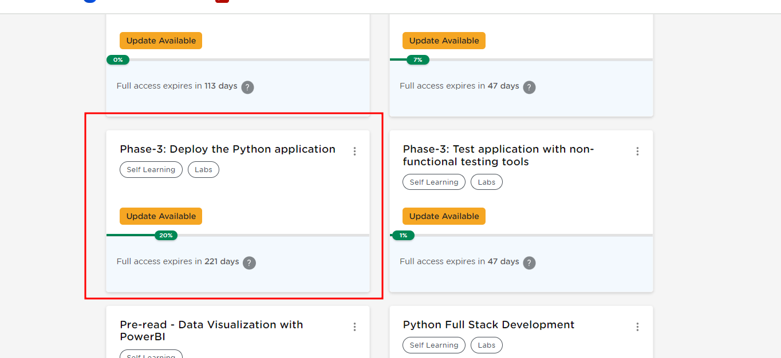

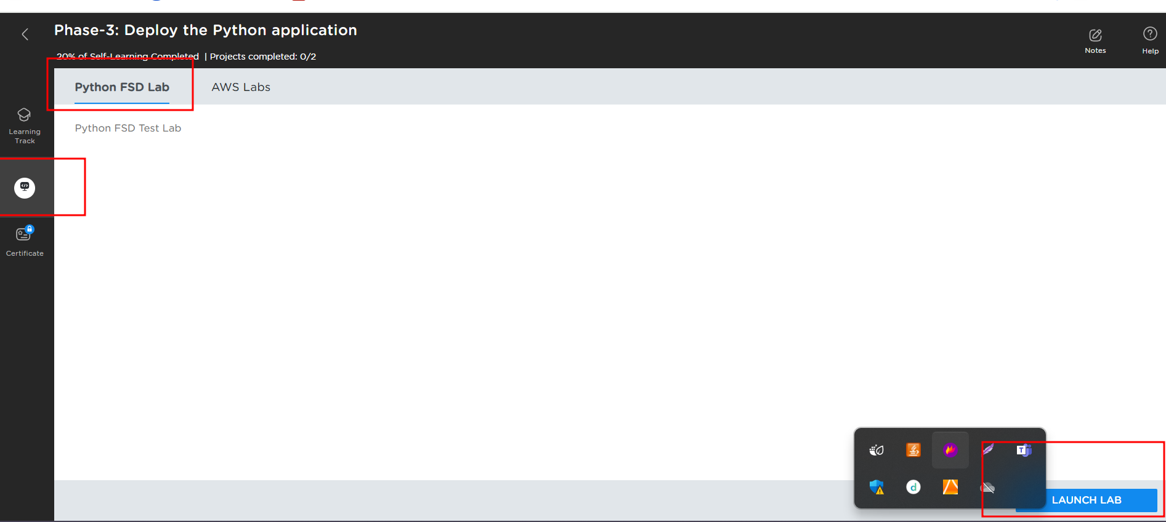

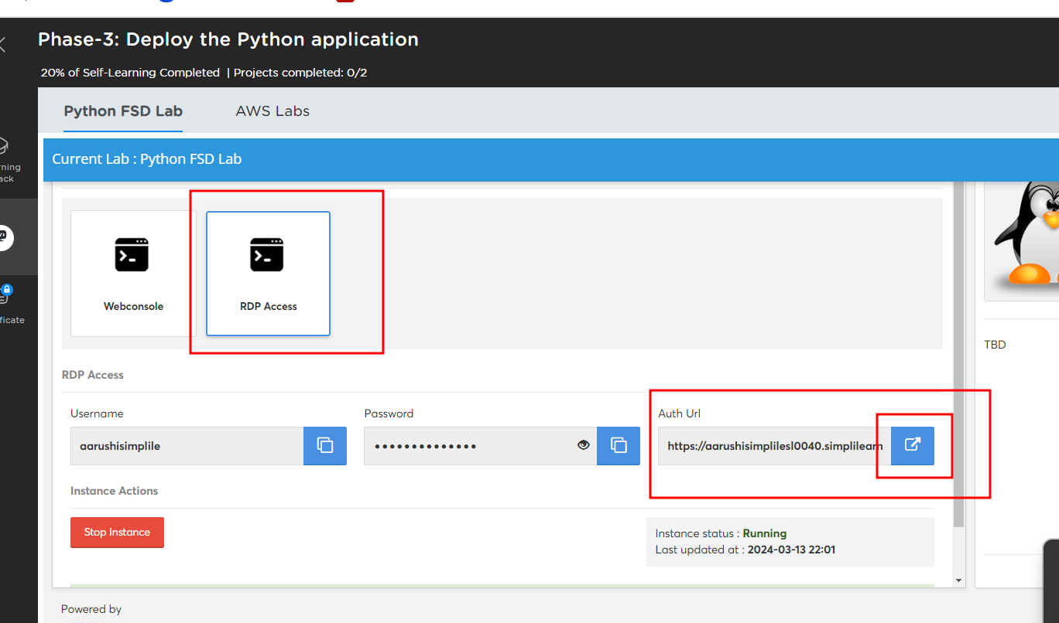

1. After open the Virtual lab. Now you need to open the terminal in virtual lab

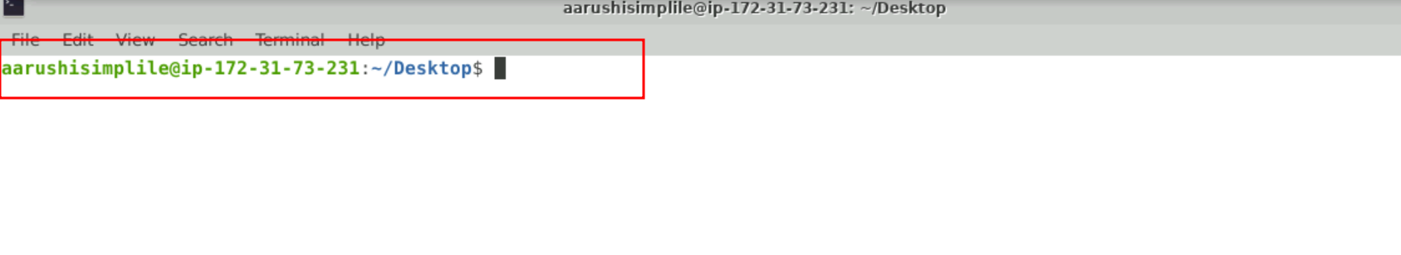

1. Using below git URL please pull the project in virtual lab.

**git clone** [**https://github.com/Kaleakash/online-baking-application-using-react-python-django.git**](https://github.com/Kaleakash/online-baking-application-using-react-python-django.git)

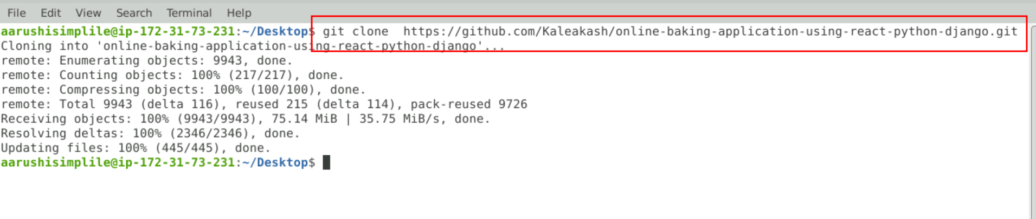

1. Move inside a project folder

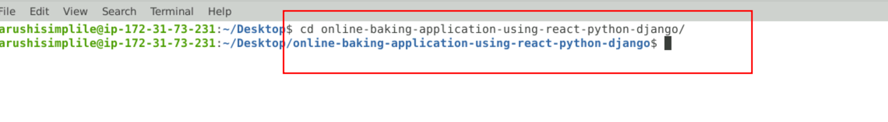

1. Now remove .git folder. Which is responsible to remove remote repository details of trainer. so you can push this code to your repository.

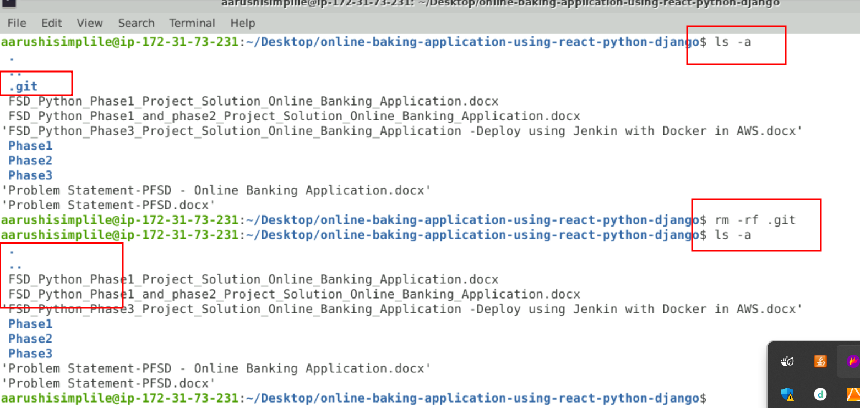

**Step 2: create docker file and docker compose file inside a project folder.**

2.1 Now move inside a phase3 folder.

2.2 Open this project in VS code using the command as **code .**

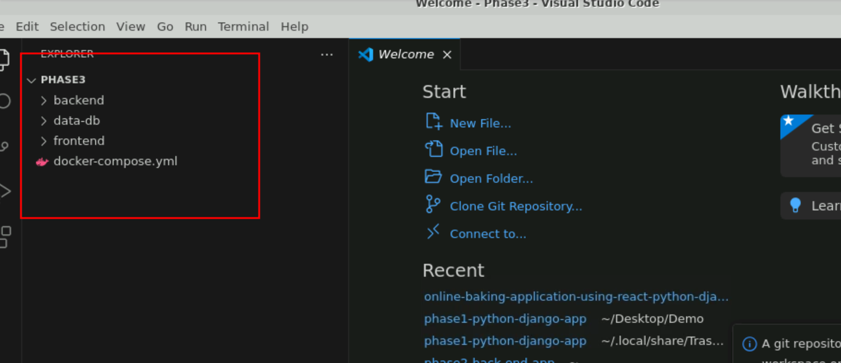

2.3 inside a backend folder contains sub folder as banking-rest-api-development-using-python

Inside this folder

**requirements.txt** file which contains all dependencies which help to run the python with Django framework.

**requirements.txt**

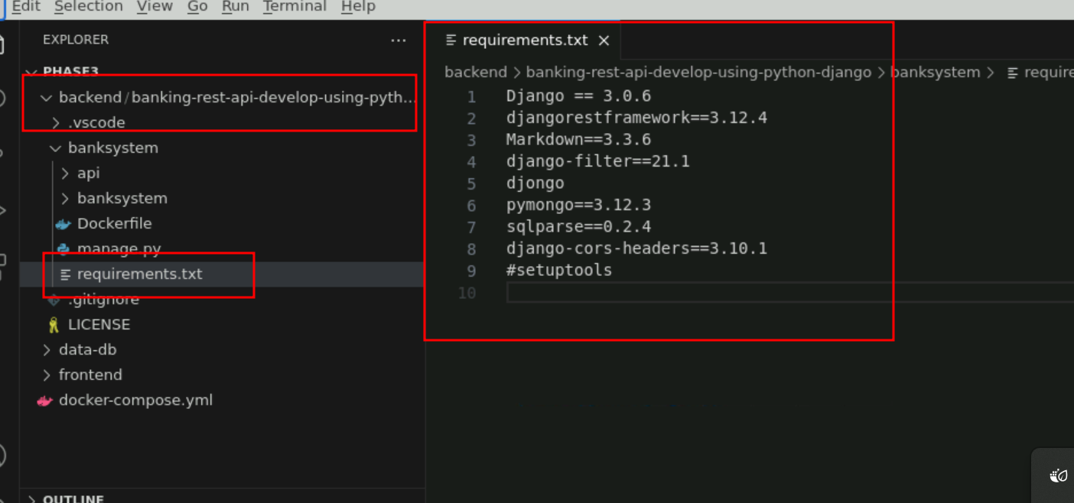

2.4 Now you need to check the Dockerfile which is responsible to create the docker images

**Dockerfile**

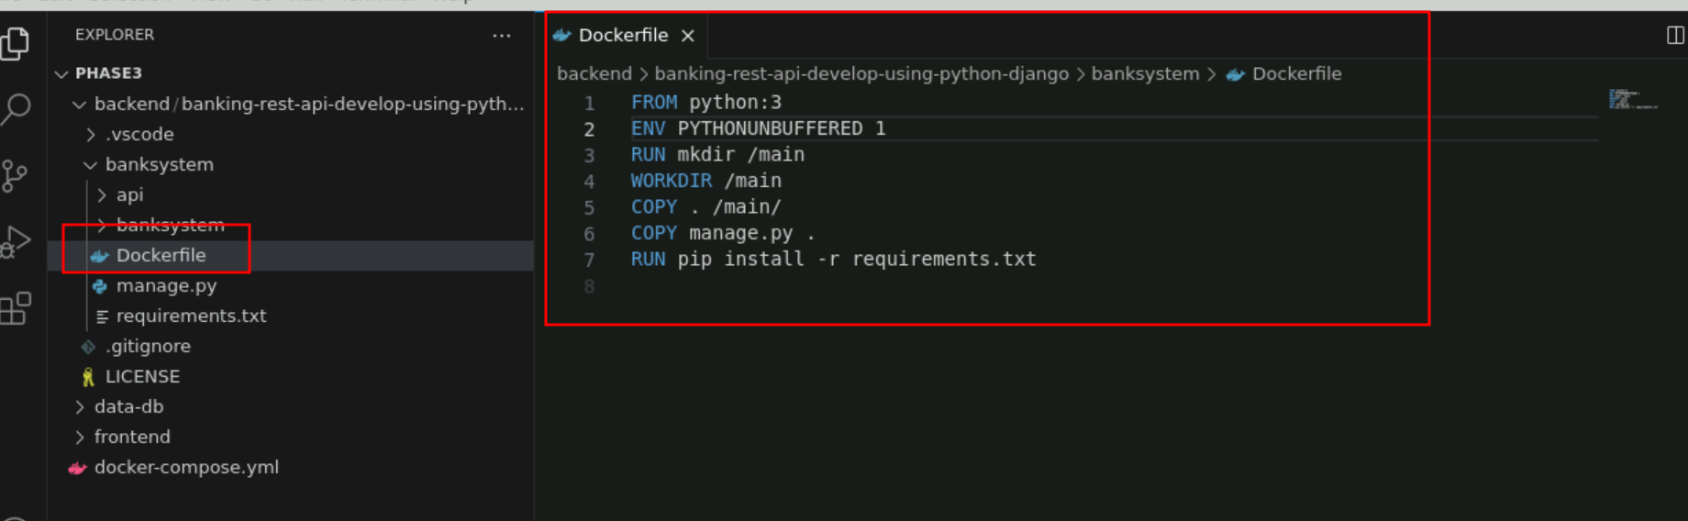

2.5 inside a frontend folder contains sub folder as my-bankin-app-frontend folder. Contains Dockerfile which is responsible to create the docker image for react js

**Dockerfile**

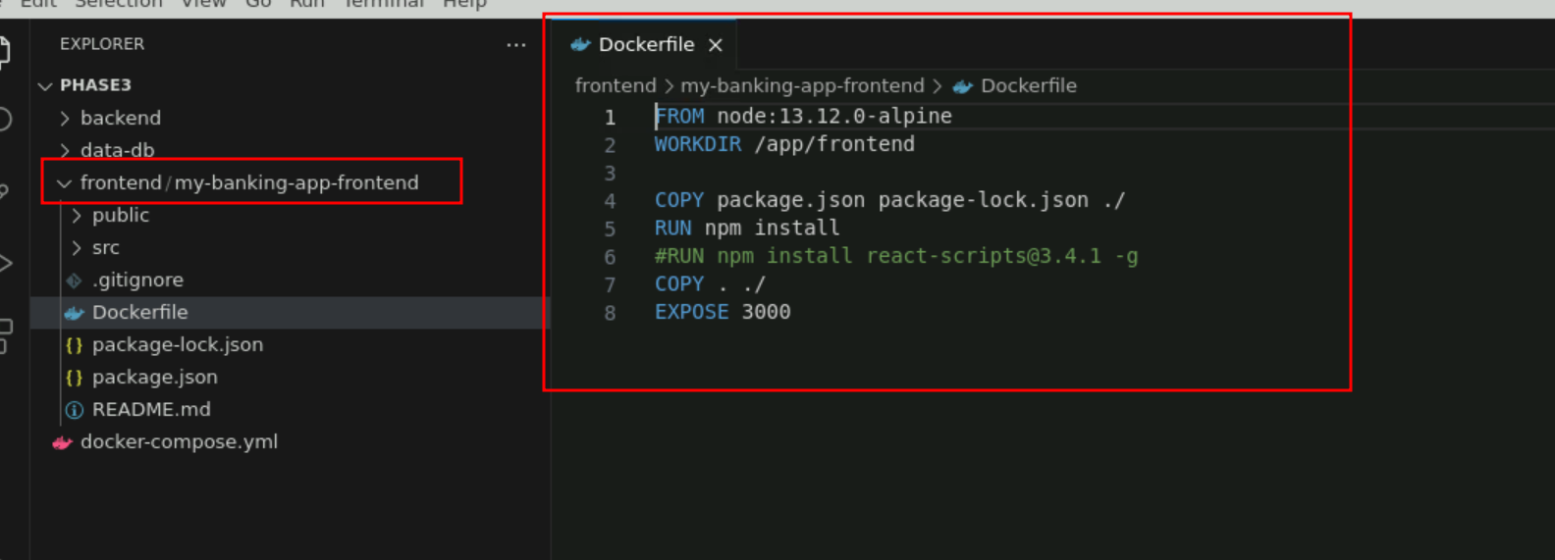

**2.6 Now we need docker-compose.yml file which is responsible to run 3 container ie react js (front end), python Django (backend) and mongo db (mongo db)**

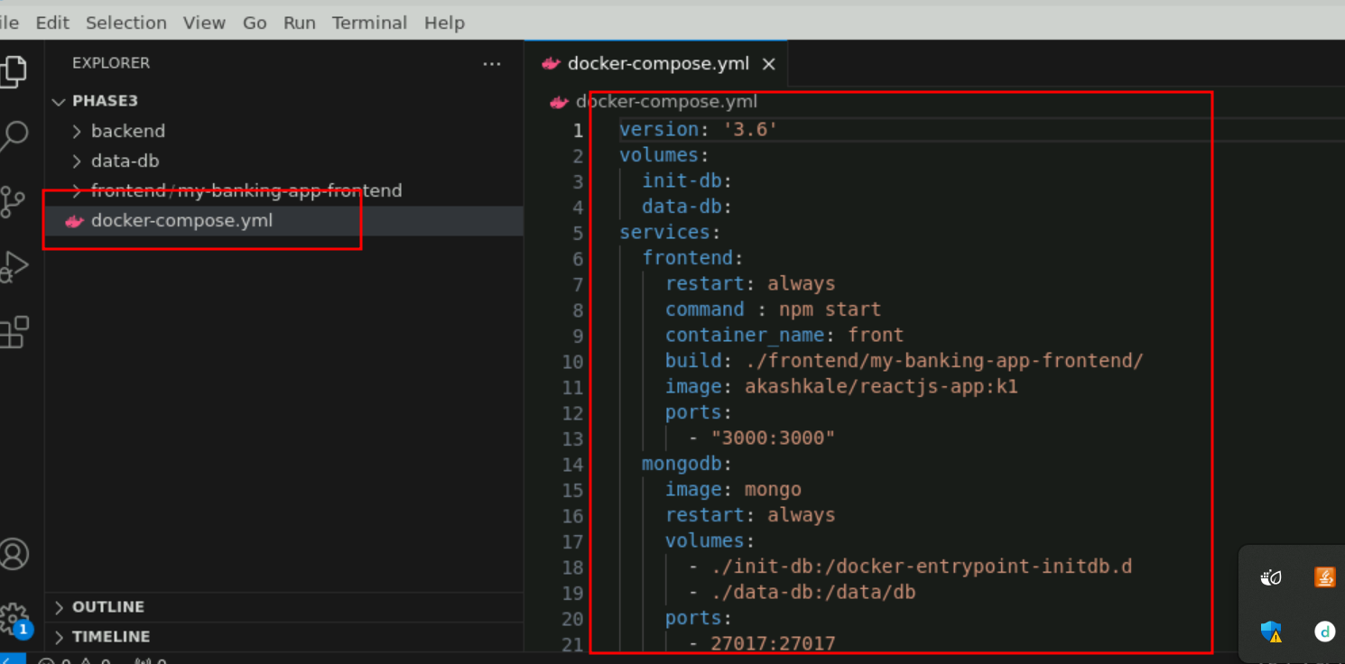

Please refer remote git repository for the code.

**Step 3: Login to AWS account:**

**3.1** Here using Python3 - Deploy the python application

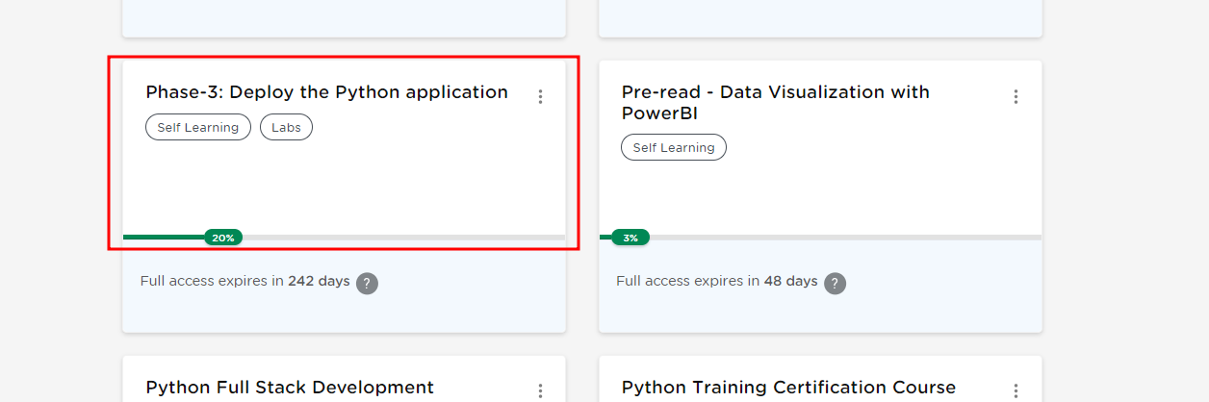

3.2 Then launch AWS lab

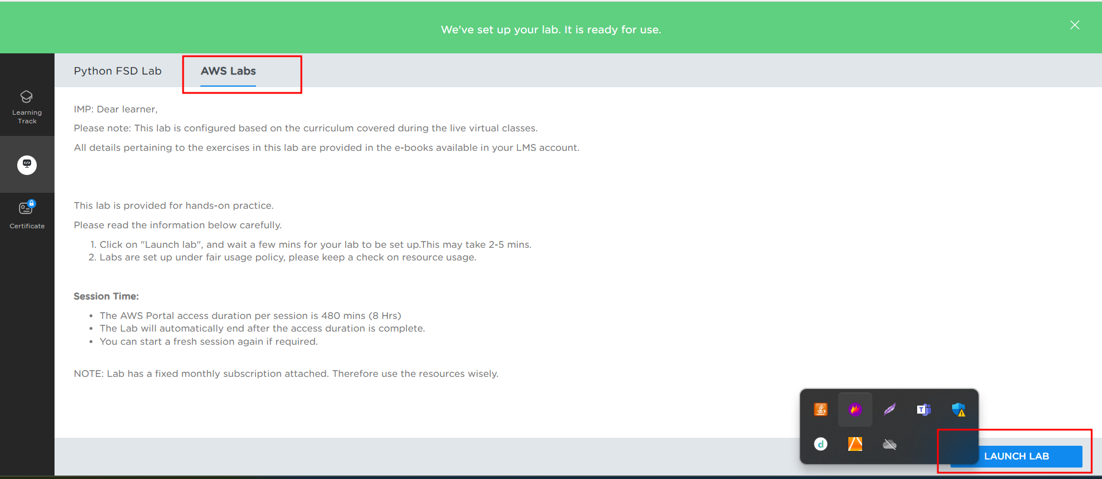

3.3 Login to AWS Account. Now click on EC2 instance which you can search in search box. If you are not able to view at the beginning.

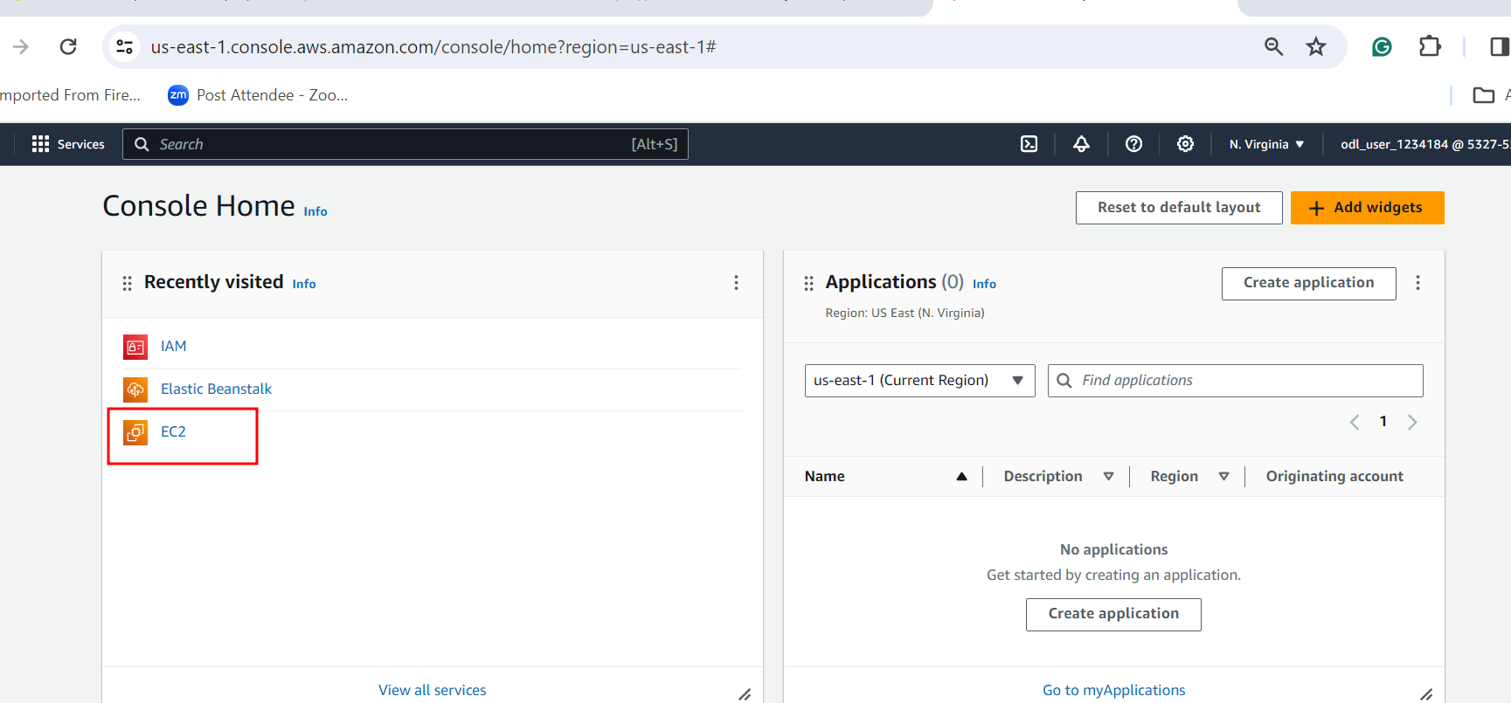

3.4 Now click on lunch instance button.

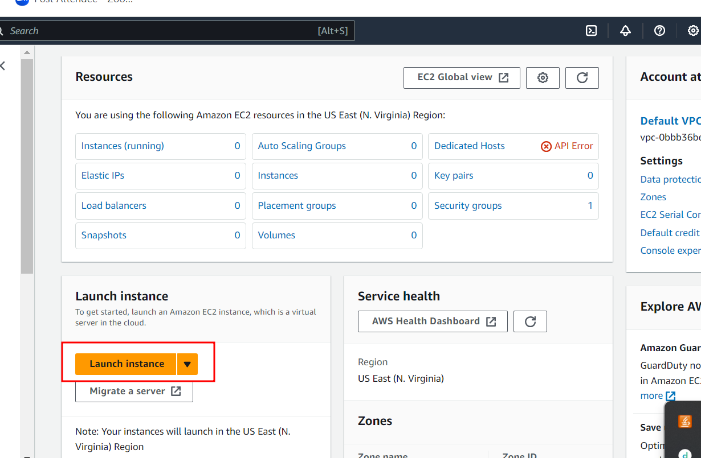

3.5 You can write any instance name and instance OS type is Amazon Linux.

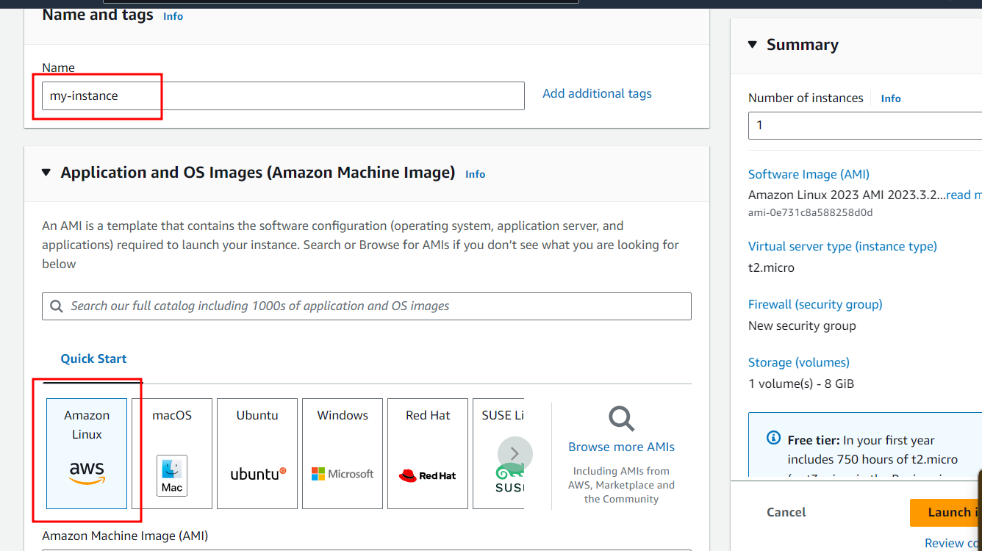

3.6 Amazon Machine Image (AMI) free tier and instance type t2.medium

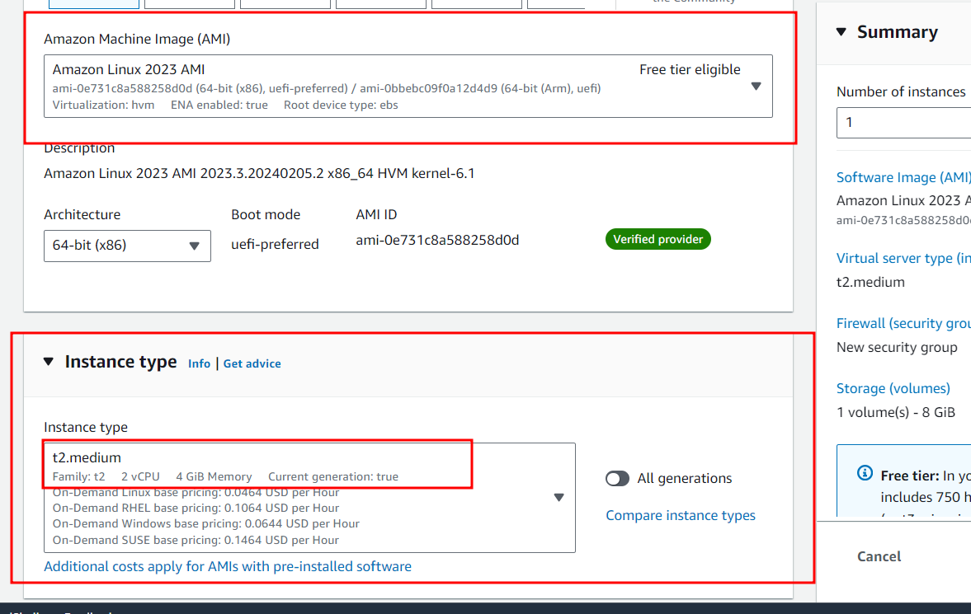

3.7 Now we need to create key-pairs which can help to connect EC2 instance using SSH client.

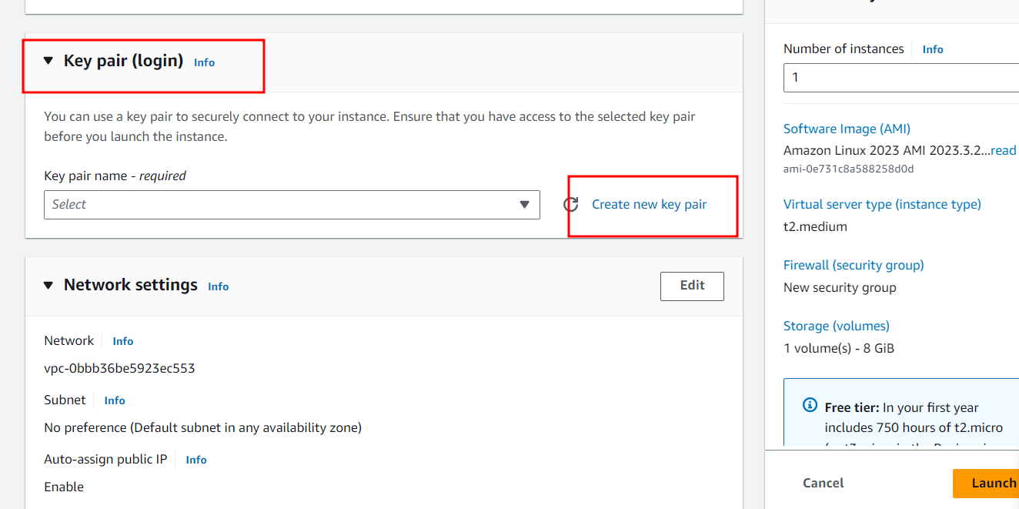

3.8 Write key name, key pair types and private key format and create the key pairs.

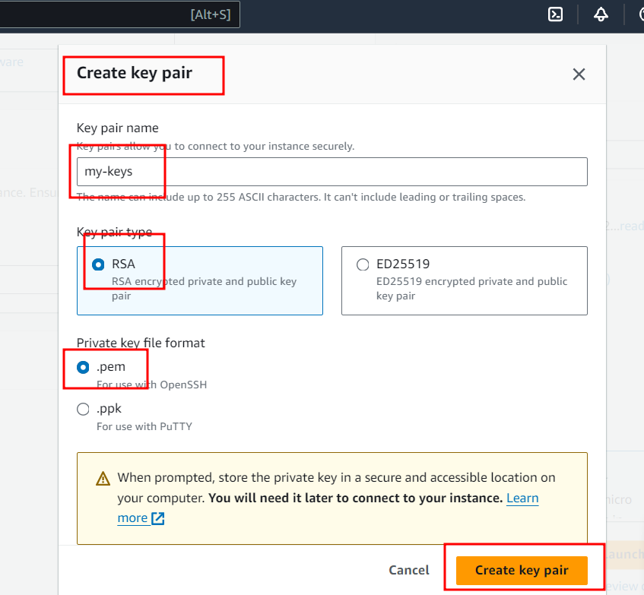

3.9. Network setting : create new security groups.

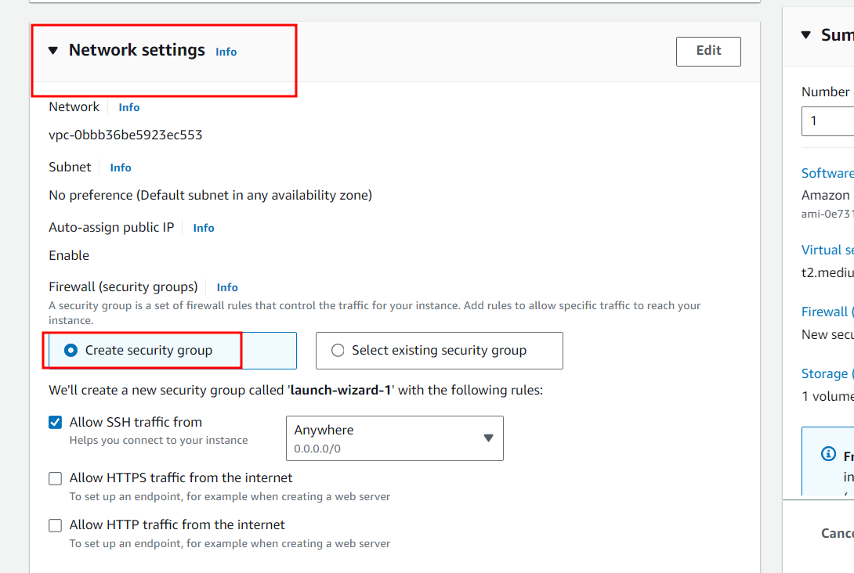

3.10 Configure storage: add new volume

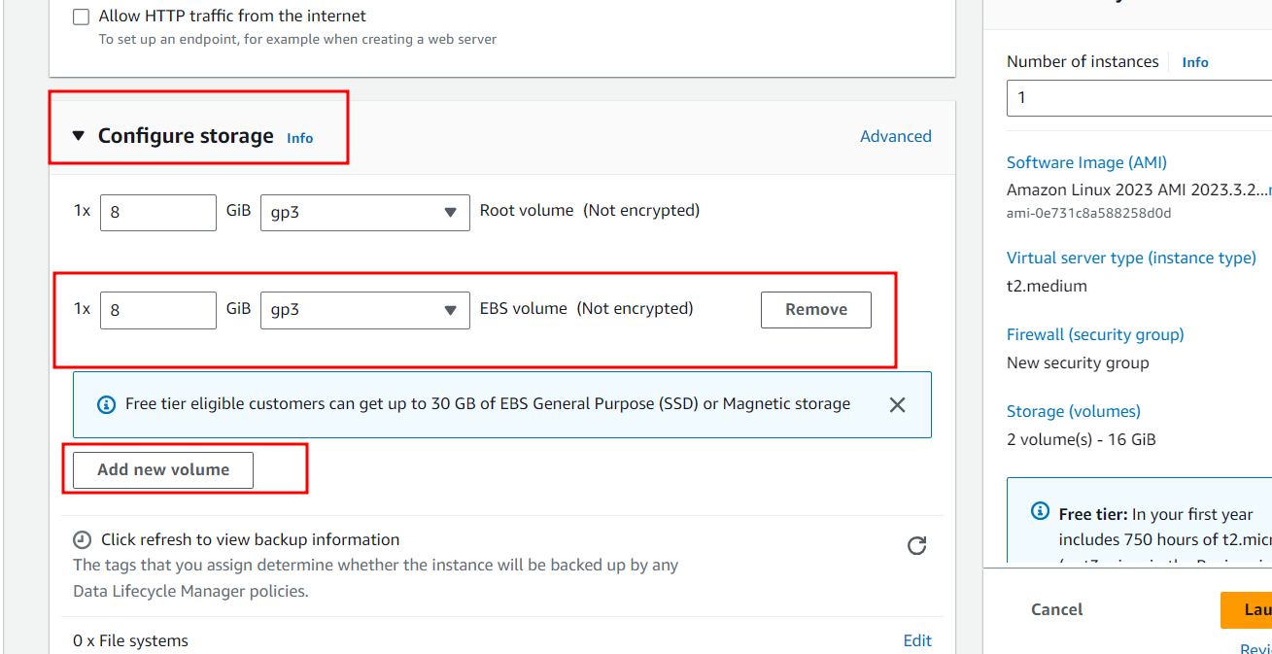

3.11 Launch instance type

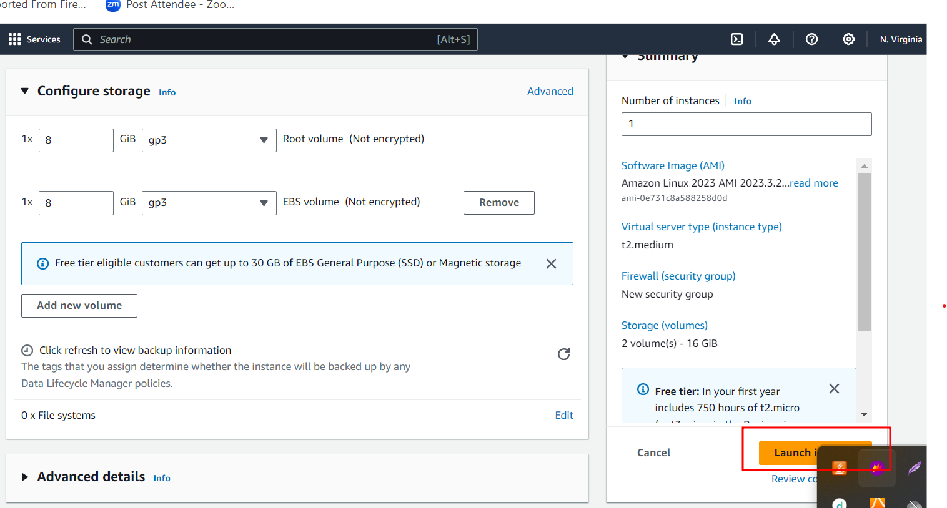

3.12 : if everything go file you can see below message.

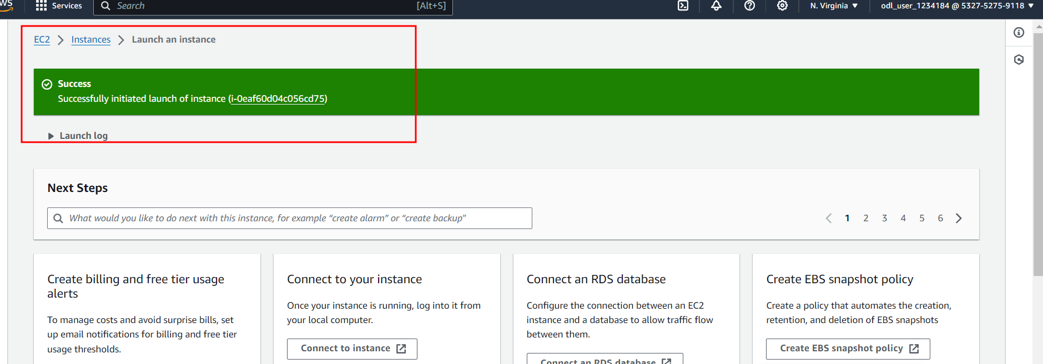

3.13 : Now you can check the status of EC2 instance. At the beginning instance is pending after few minutes it start running

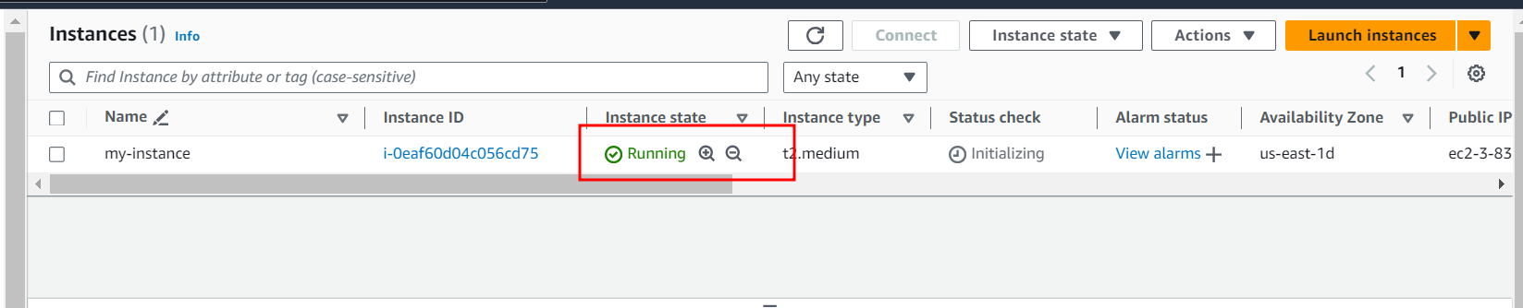

3.14. Now we need to open the port number to run the application. By default EC2 instance open 22 port number to connect EC2 instance using SSH client. So Jenkin use port number 8080, React JS use 3000 and Python with Django 8000.

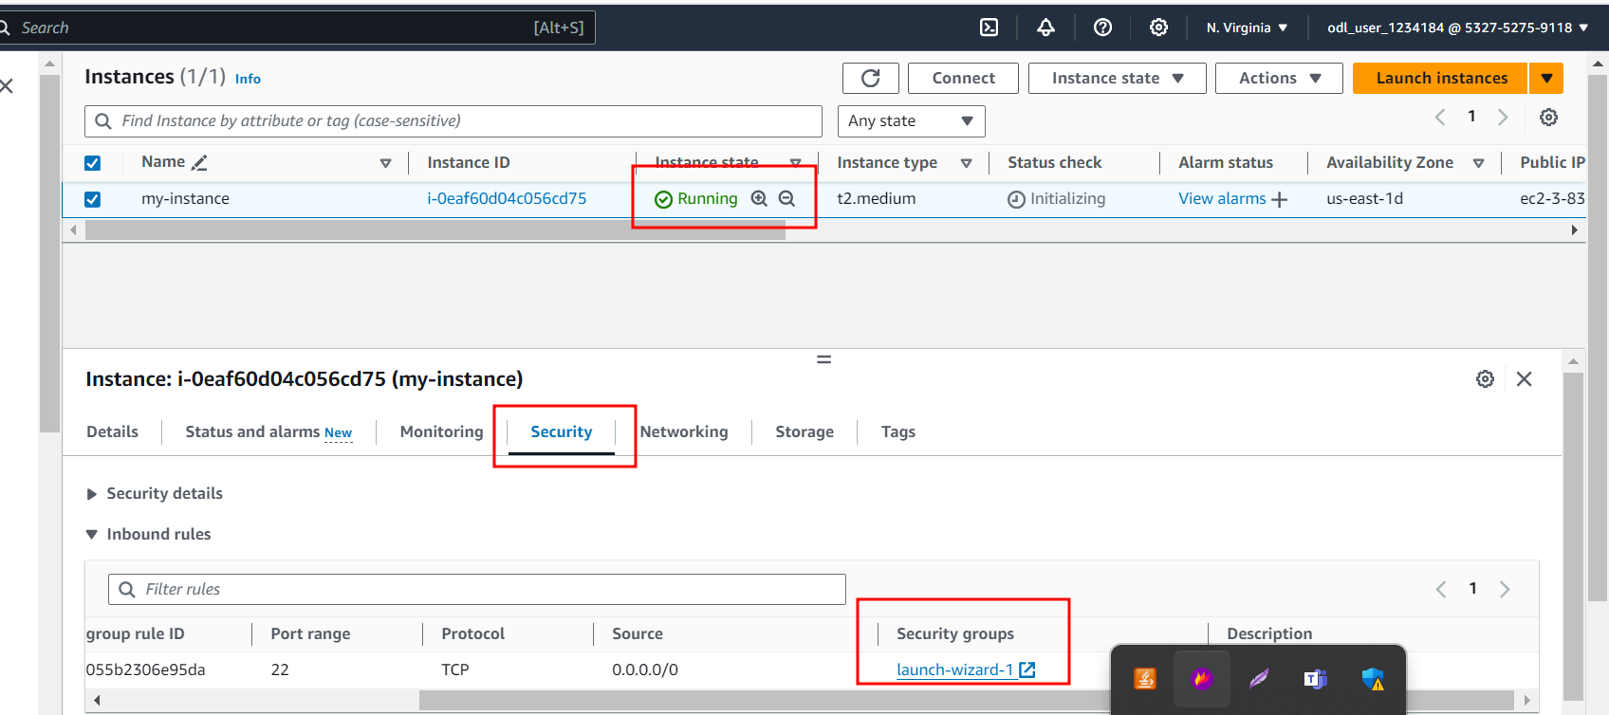

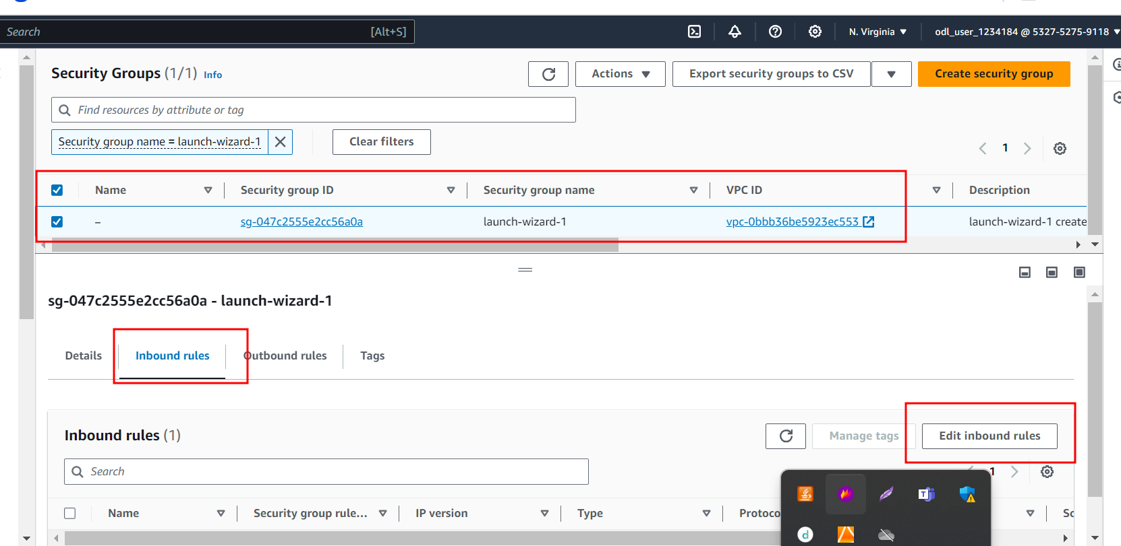

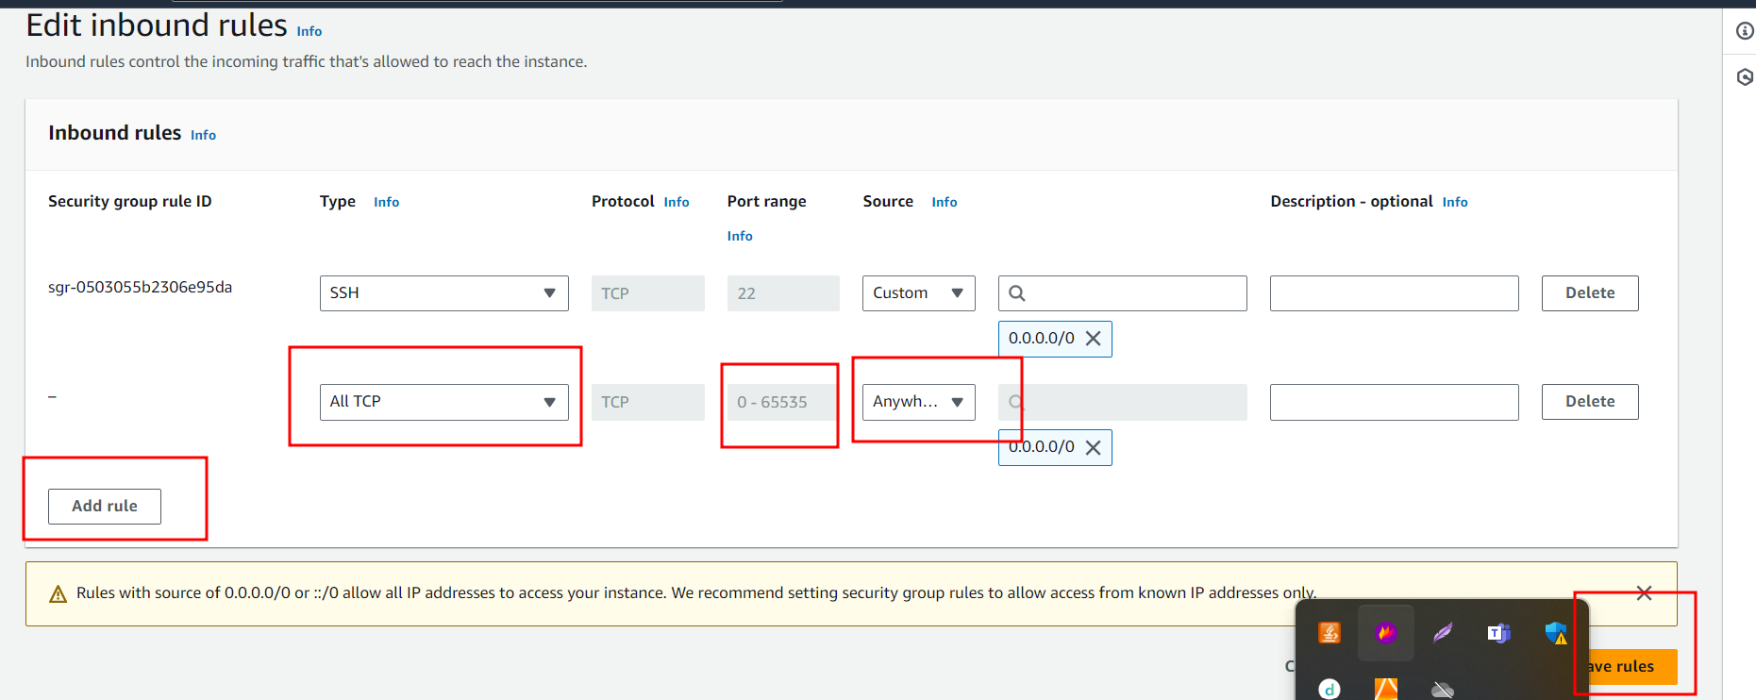

The above steps open All TCP port number from 0 to 65535.

3.15. Now you can connect the EC2 instance using browser or SSH client. Here I am using browser.

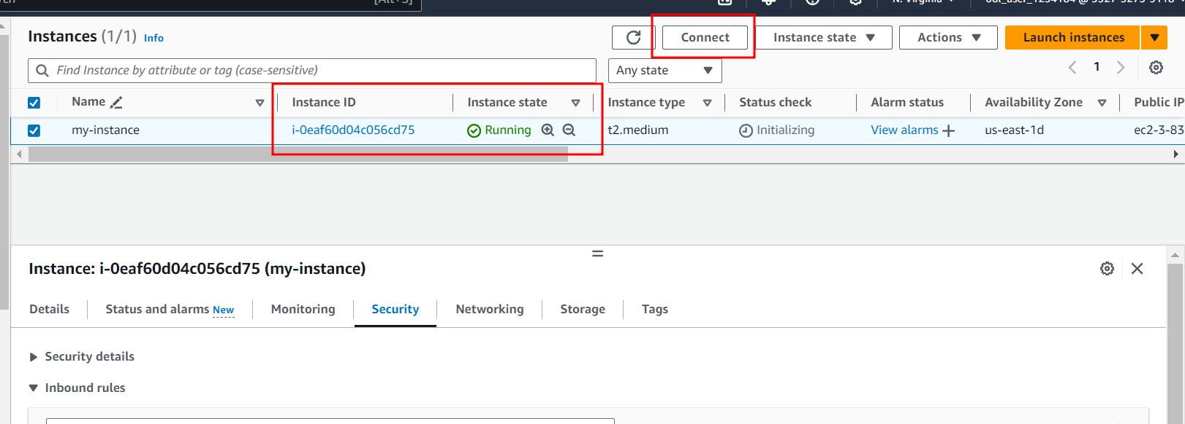

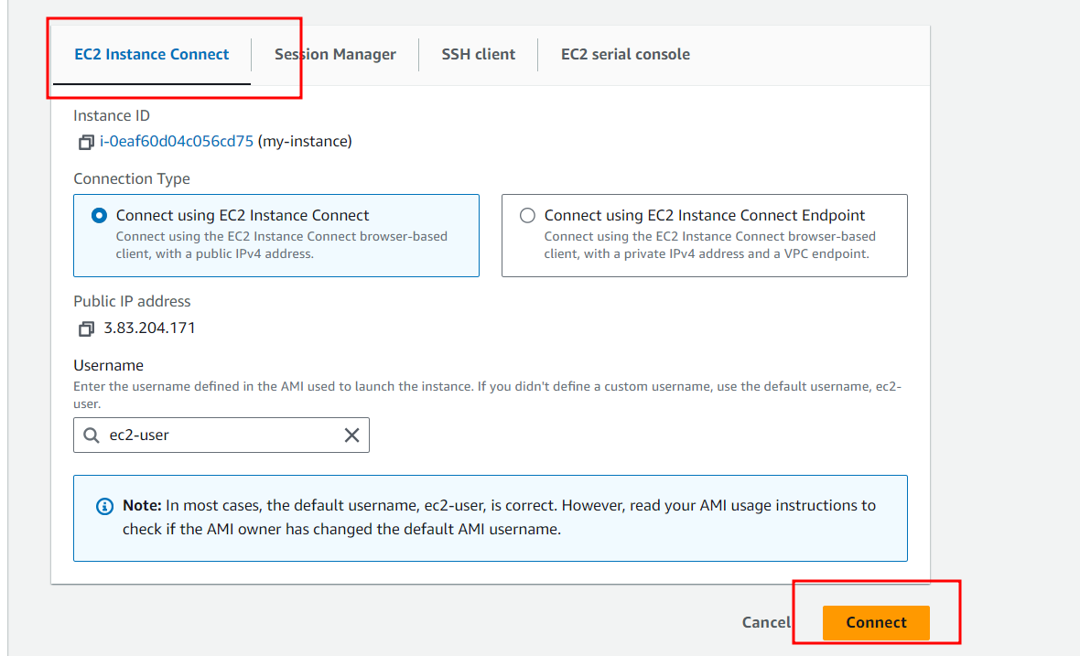

3.16 : You instance connected through browser. This instance provide public as well as private IP Address.

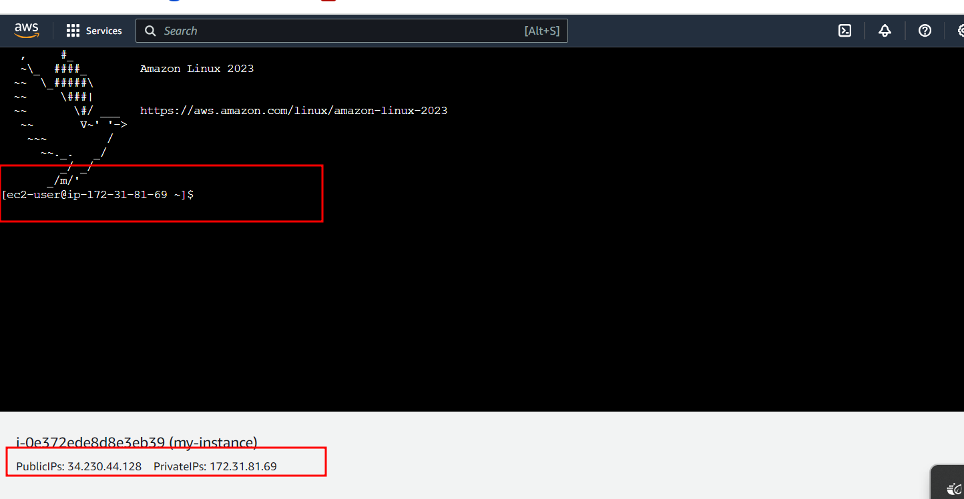

Step 4 : You need to push phase3 folder to your remote repository.

4.1 : Before creating and push In Virtual Lab Please do some changes in setting.py file. Change the Public IP Address of your current instance.

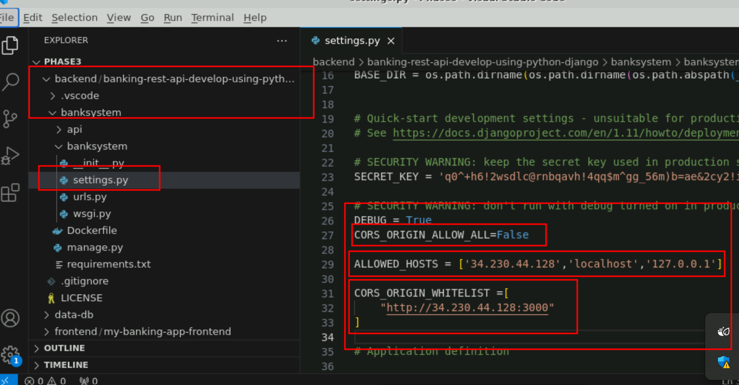

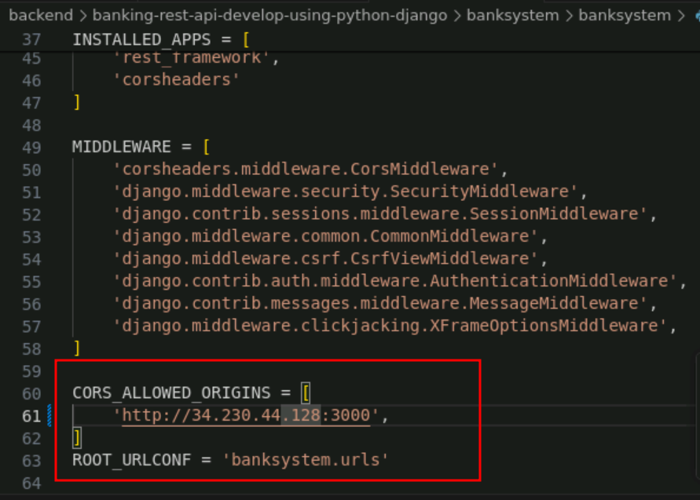

Here IP Address must be your EC2 instance public id address.

4.2 In React JS Project please change the public ip address in service folder both the file.

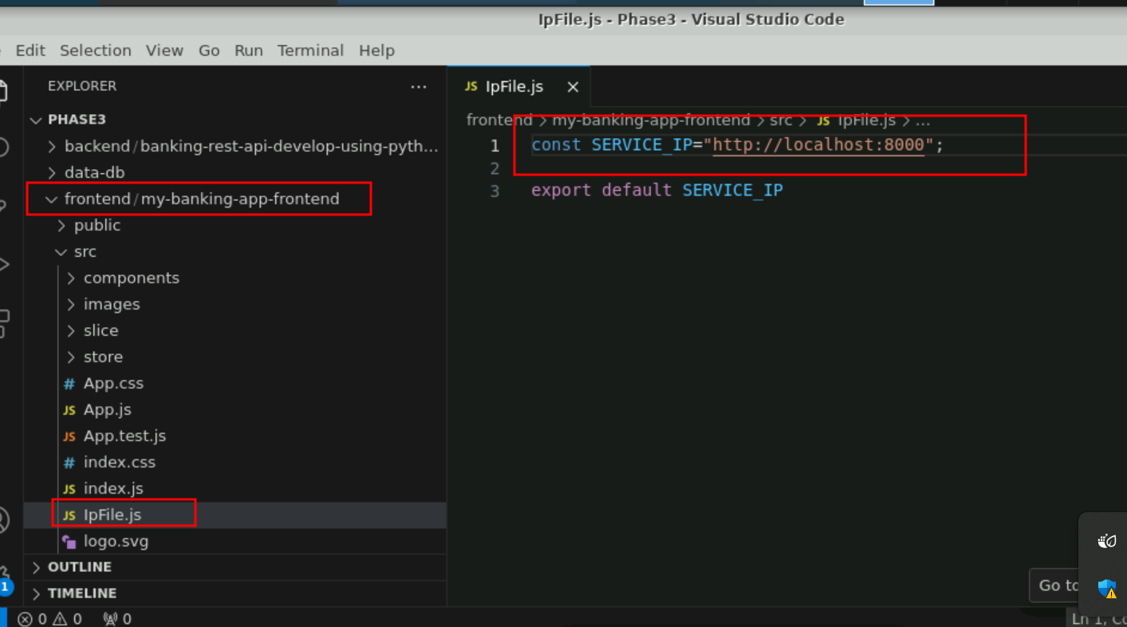

In this localhost replace by your EC2 instance public ip address.

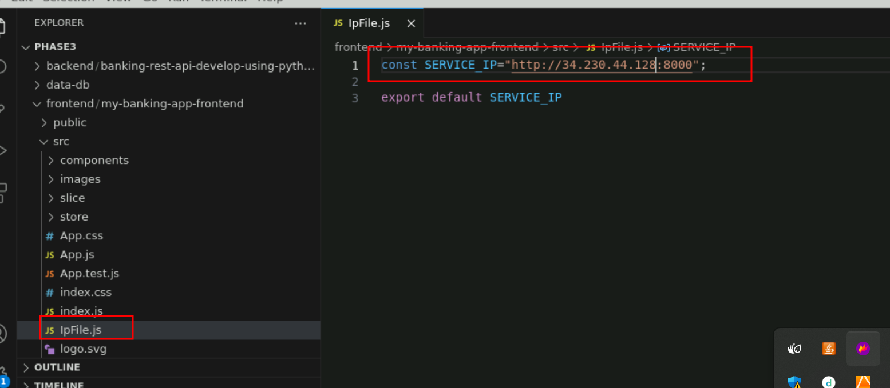

4.3 Follow below step to push your code to git hub account from Virtual Lab. Before push please create github account.

Inside a phase 3 folder execute below command to make this folder as local repository.

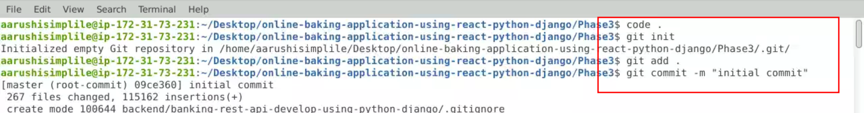

git init

git add .

git commit -m “initial commit”

Now you need to create Remote repository in your account

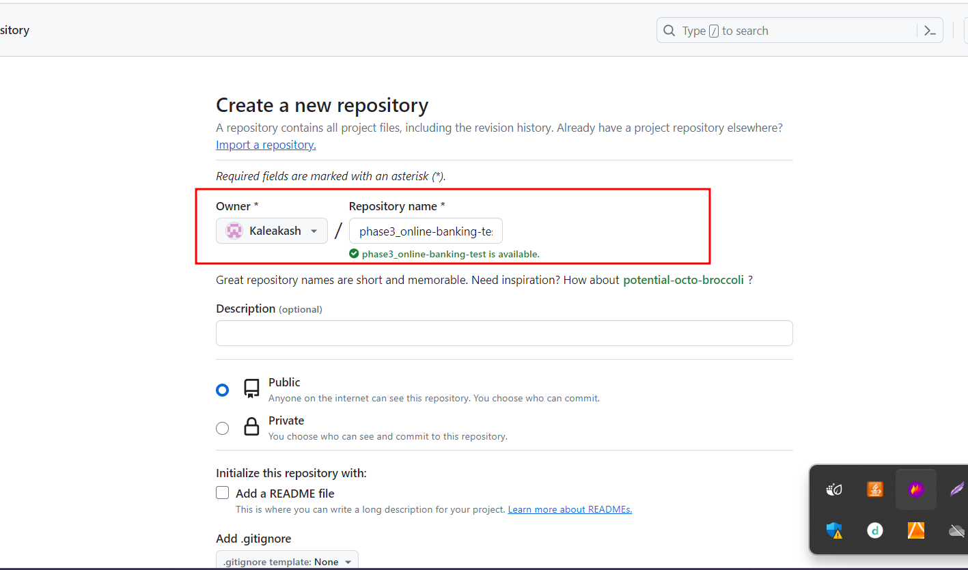

You need to connect your local repository with remote repository. You can connect with lot of way. Here I am doing using token base.

After create repository please copy highlighted command on notepad which required for use to add the token for that

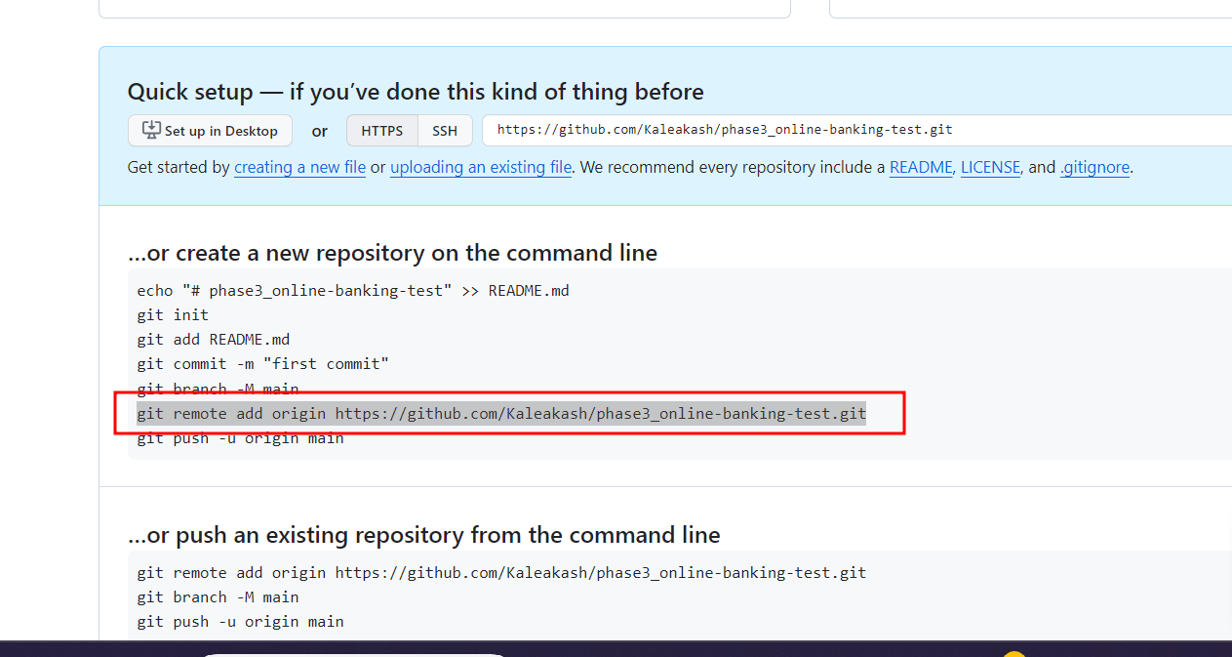

Now steps to create the Token

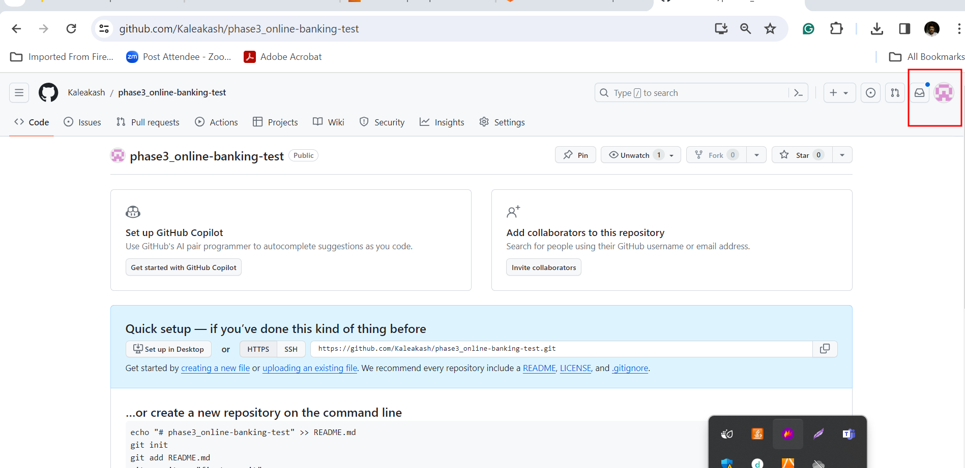

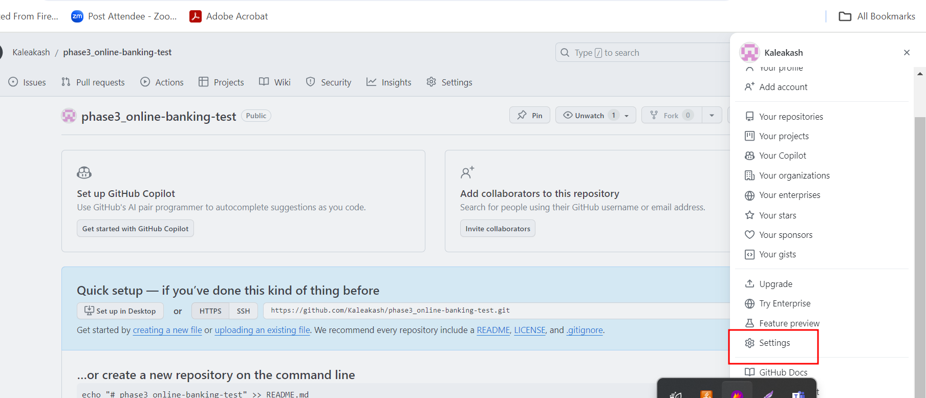

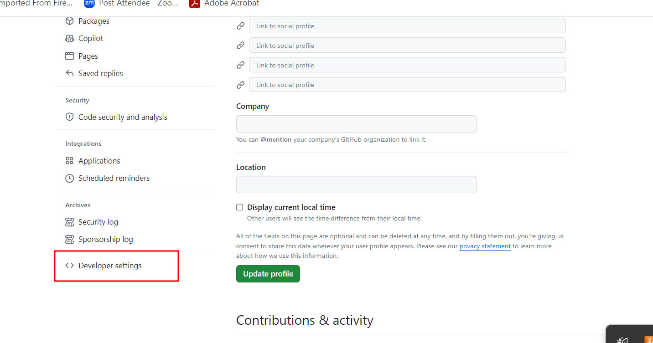

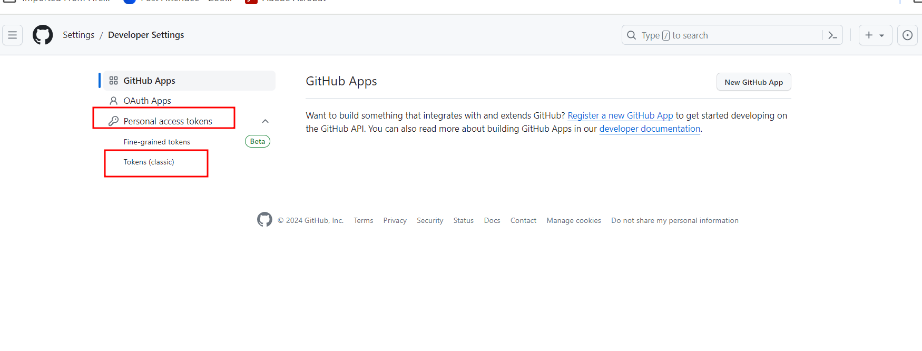

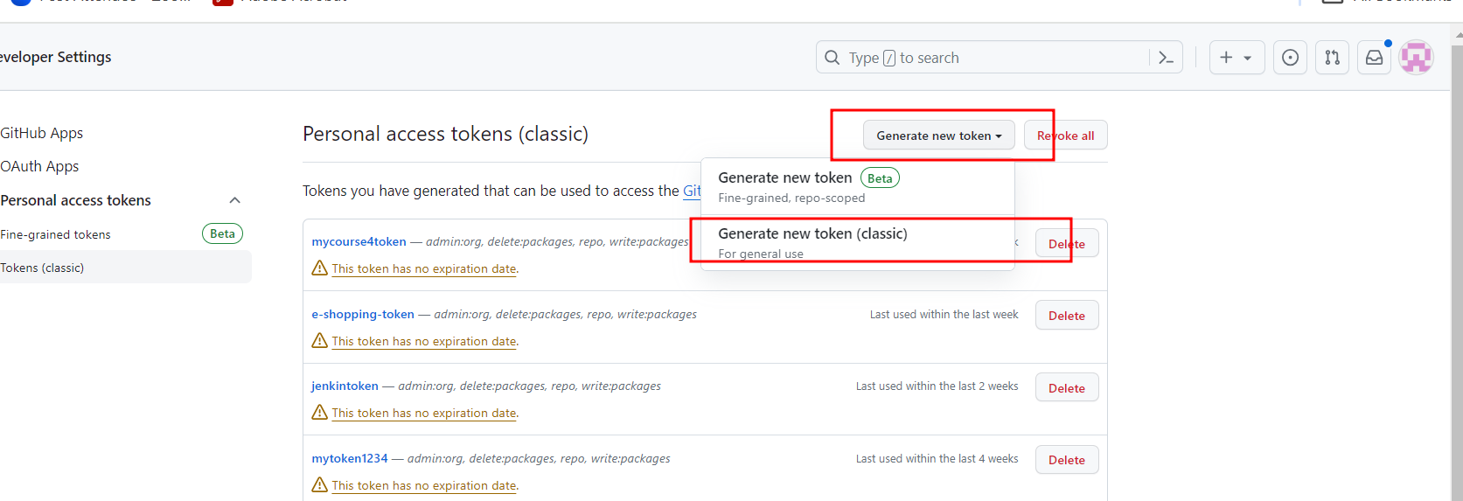

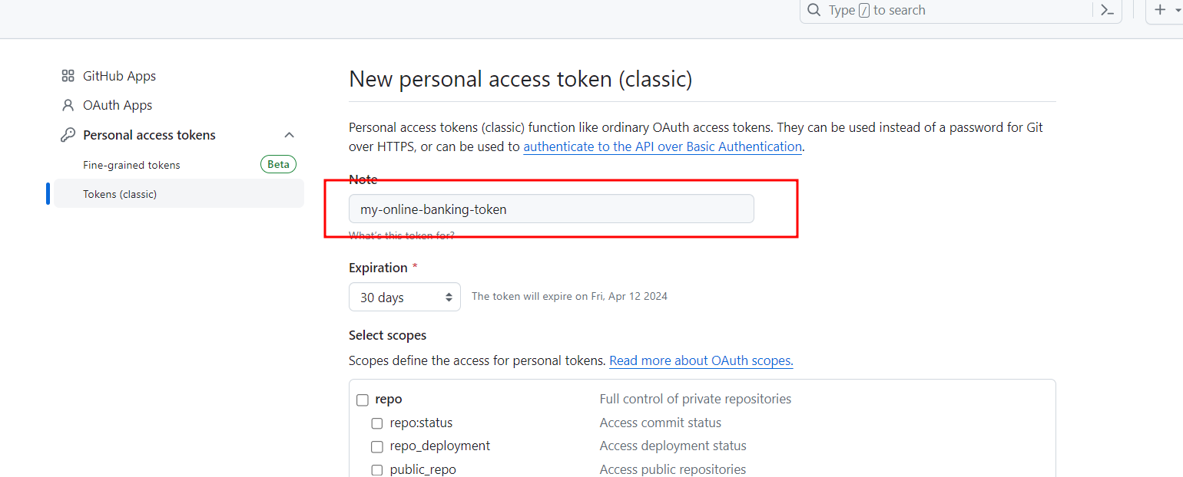

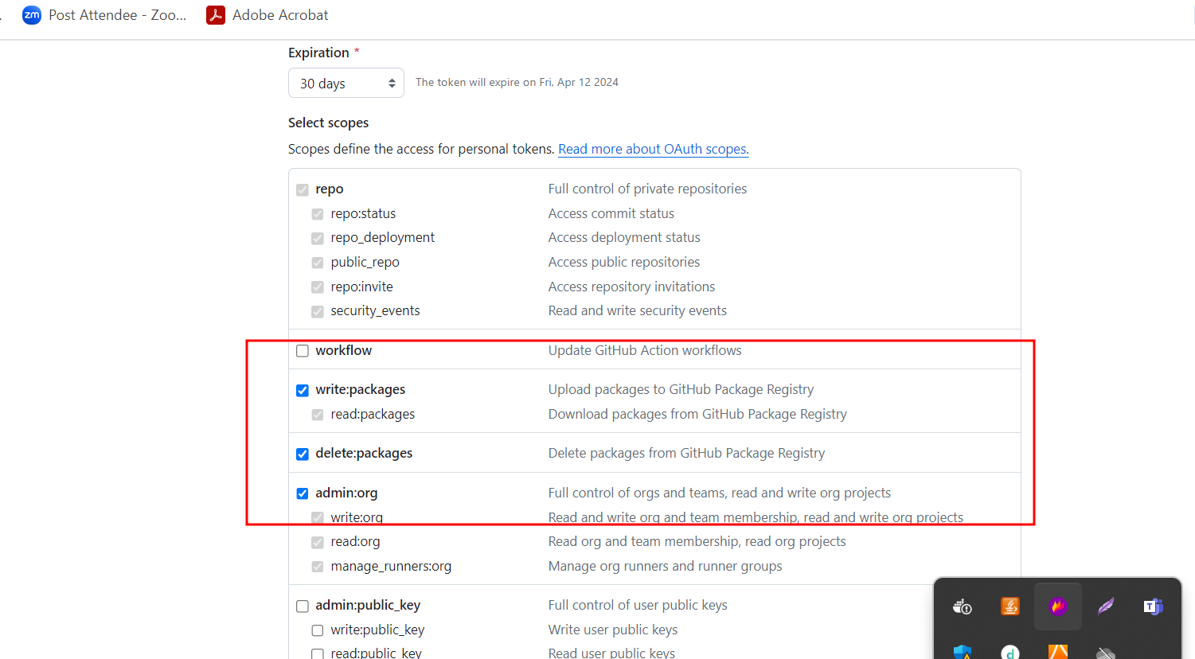

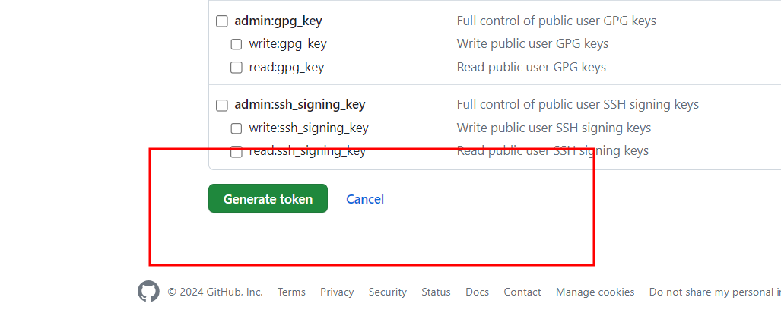

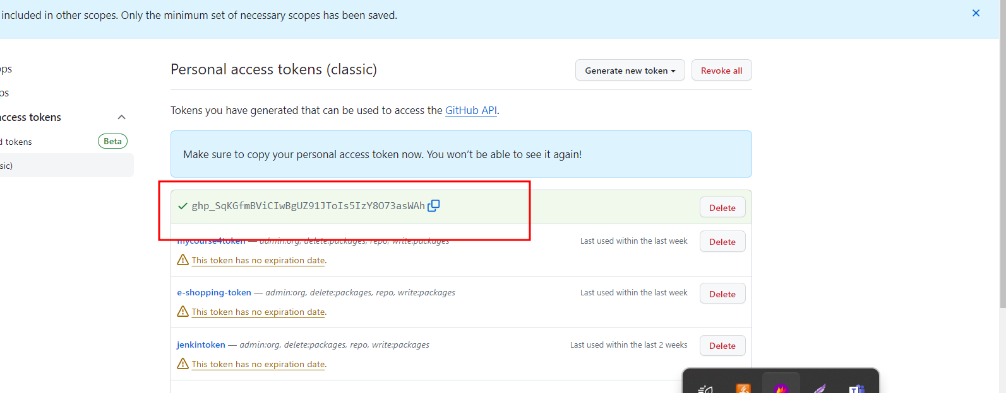

git remote add origin <https://token@github.com/Kaleakash/phase3_online-banking-test.git>

make sure there is no space in token

if you done any mistake, please remove that origin using the below command.

git remote rm origin

and re try

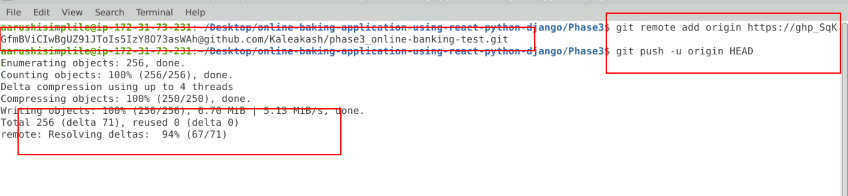

Please verify your code in remote repository

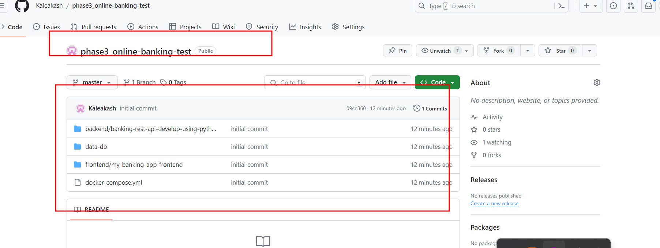

**Step 5 : Install all required software to in EC2 instal to deploy ie git, Java, Jenkin, docker and docker compose**

5.1 : now open EC2 instance browser base terminal

5.2 install git software which help to pull the project from git hub repository.

**sudo yum install git -y**

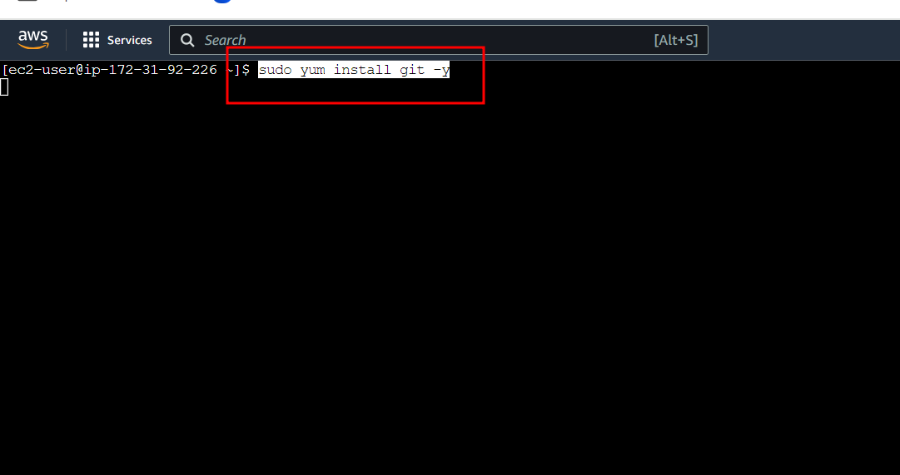

5.2 check the git version

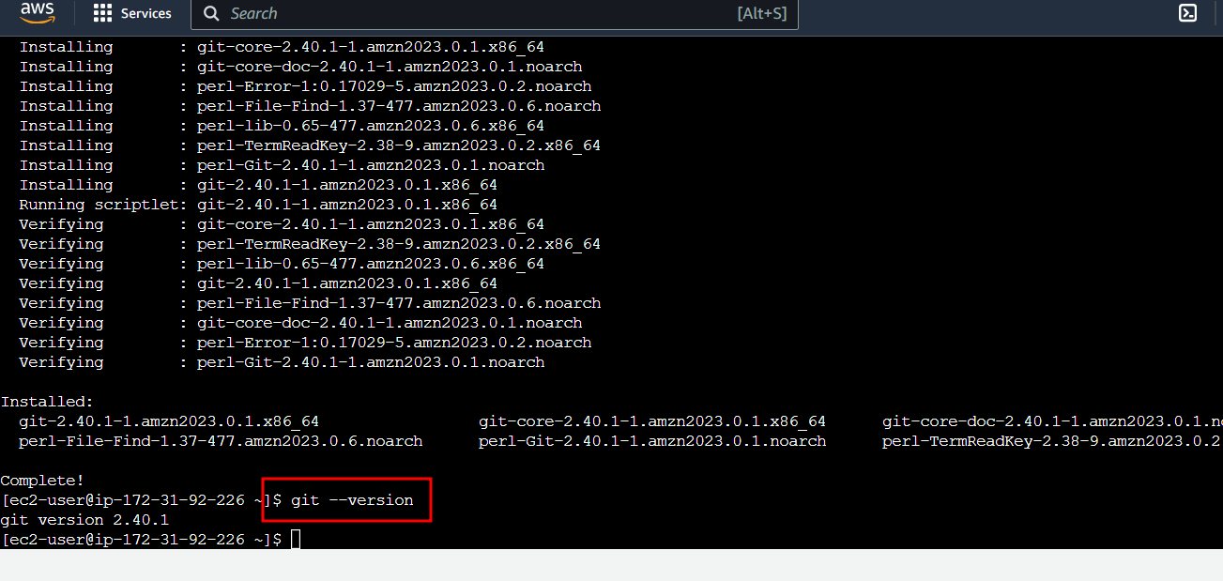

5.3 Now we need to install Java. Because Jenkin CI and CD tool is base upon java software.

**sudo yum install java**

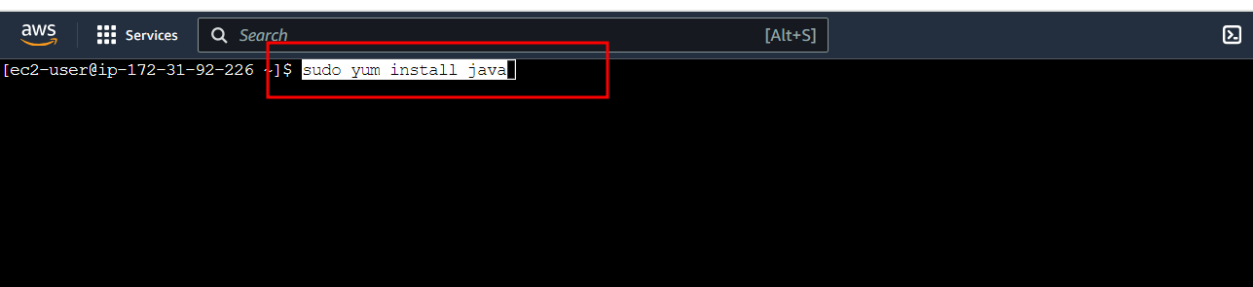

**5.4 Now check Java version**

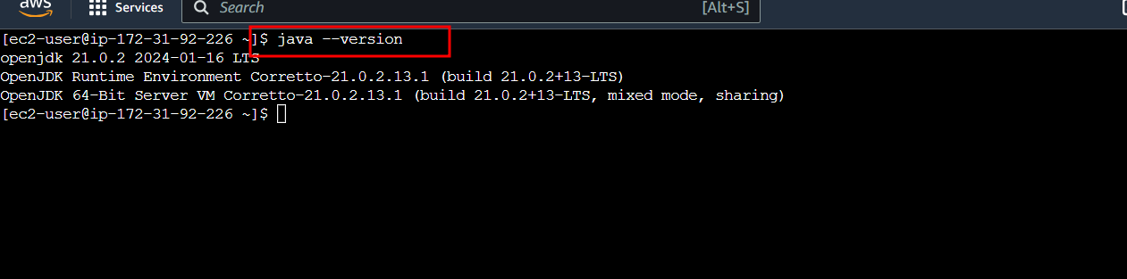

**5.5 Now we need to install the Jenkin software**

This below command to download the Jenkin software.

**sudo wget -O /etc/yum.repos.d/jenkins.repo** [**https://pkg.jenkins.io/redhat/jenkins.repo**](https://pkg.jenkins.io/redhat/jenkins.repo)

import the Jenkin keys.

**sudo rpm --import** [**https://pkg.jenkins.io/redhat-stable/jenkins.io-2023.key**](https://pkg.jenkins.io/redhat-stable/jenkins.io-2023.key)

Install the Jenkin software

**sudo yum install jenkins**

start the Jenkin service

**sudo service jenkins start**

To check the Jekin software status

**sudo systemctl status jenkins**

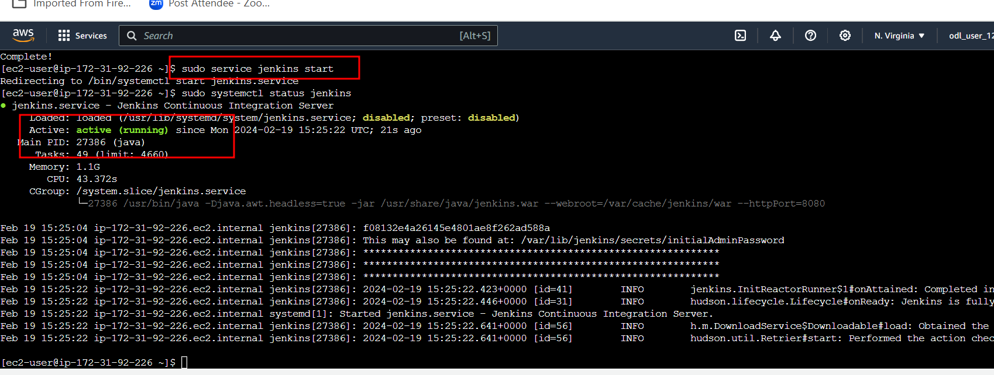

Note : use Cntr + C or Cntr + D to terminate that screen.

The initial admin password

**sudo cat /var/lib/jenkins/secrets/initialAdminPassword**

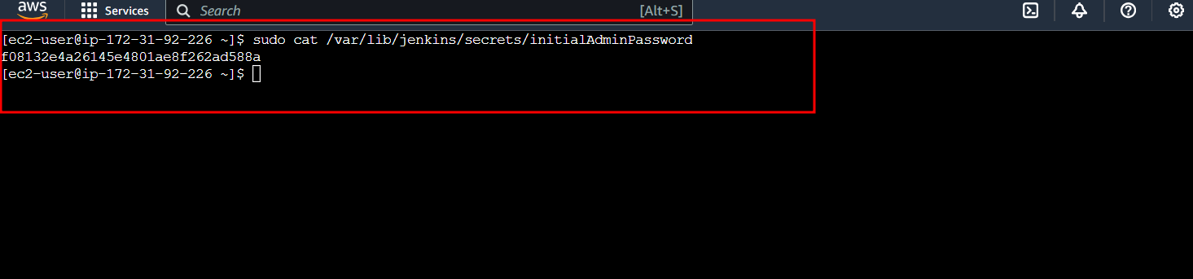

**5.6 Now open the Jenkin with your instance public IP Address with port number 8080**

[**http://publicIdAddress:8080**](http://publicIdAddress:8080)

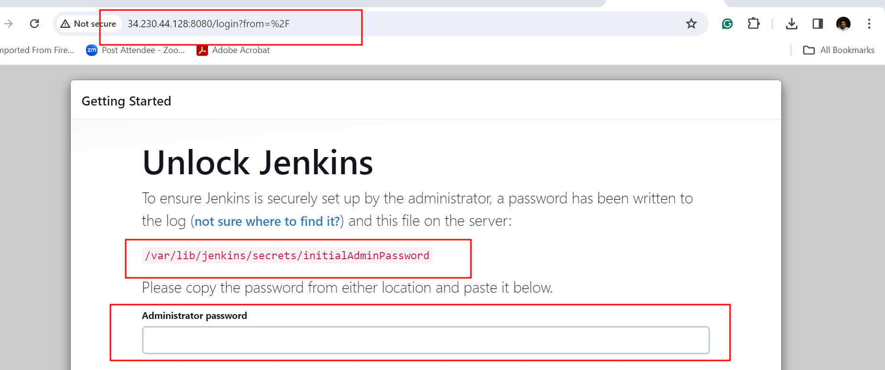

**5.7 Please copy and paste password from EC2 instance terminal. It initial instal the suggested plugin**

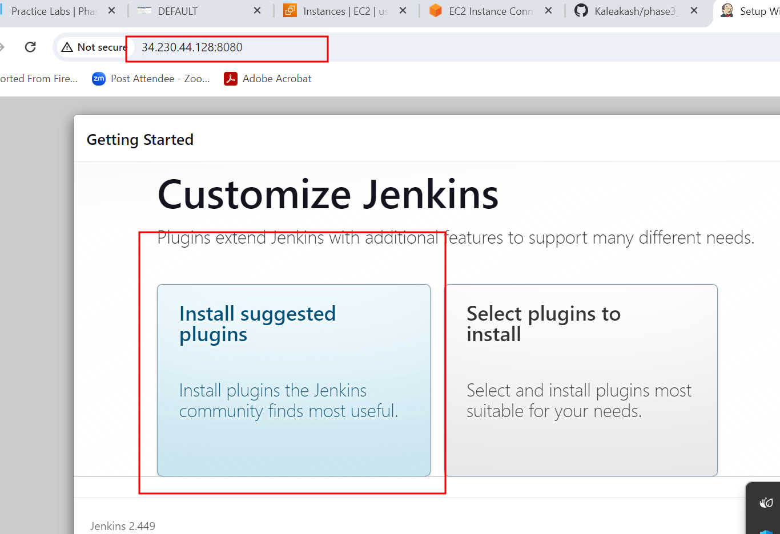

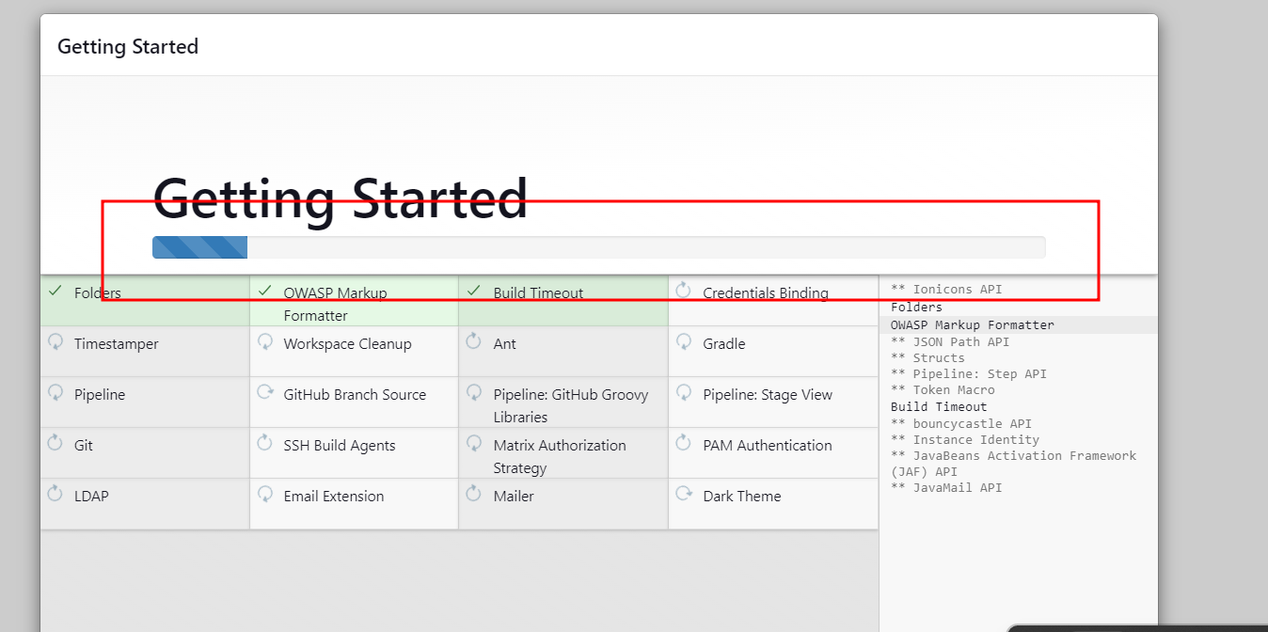

**5.8 : create the account with your personal details.**

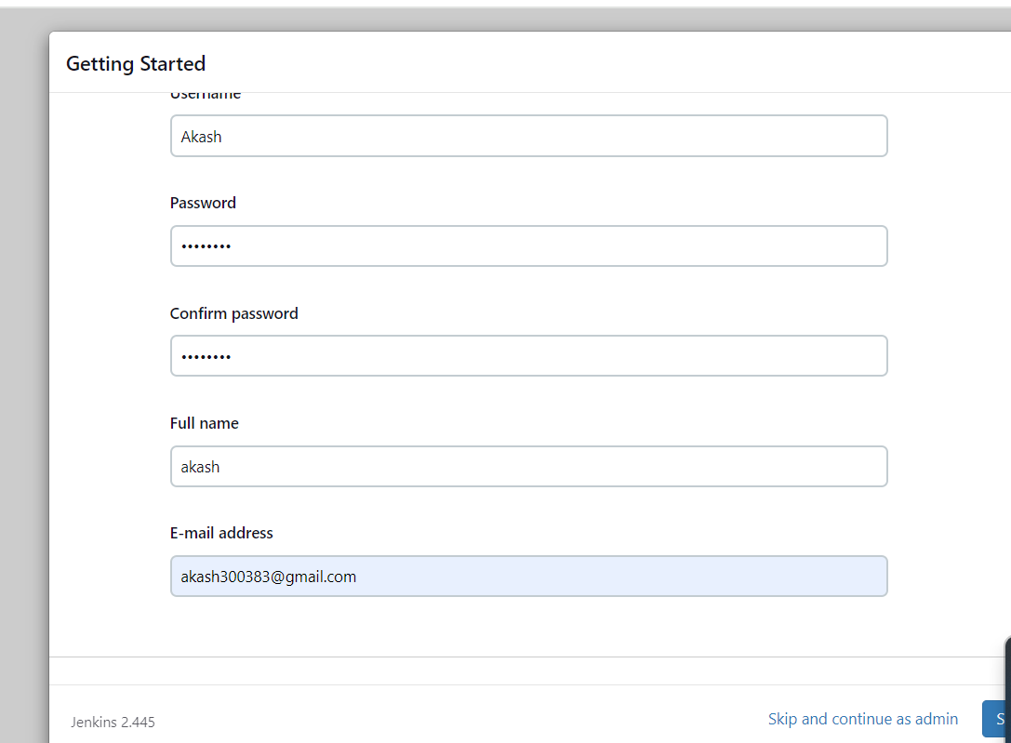

**5.9 here you can click save and finish.**

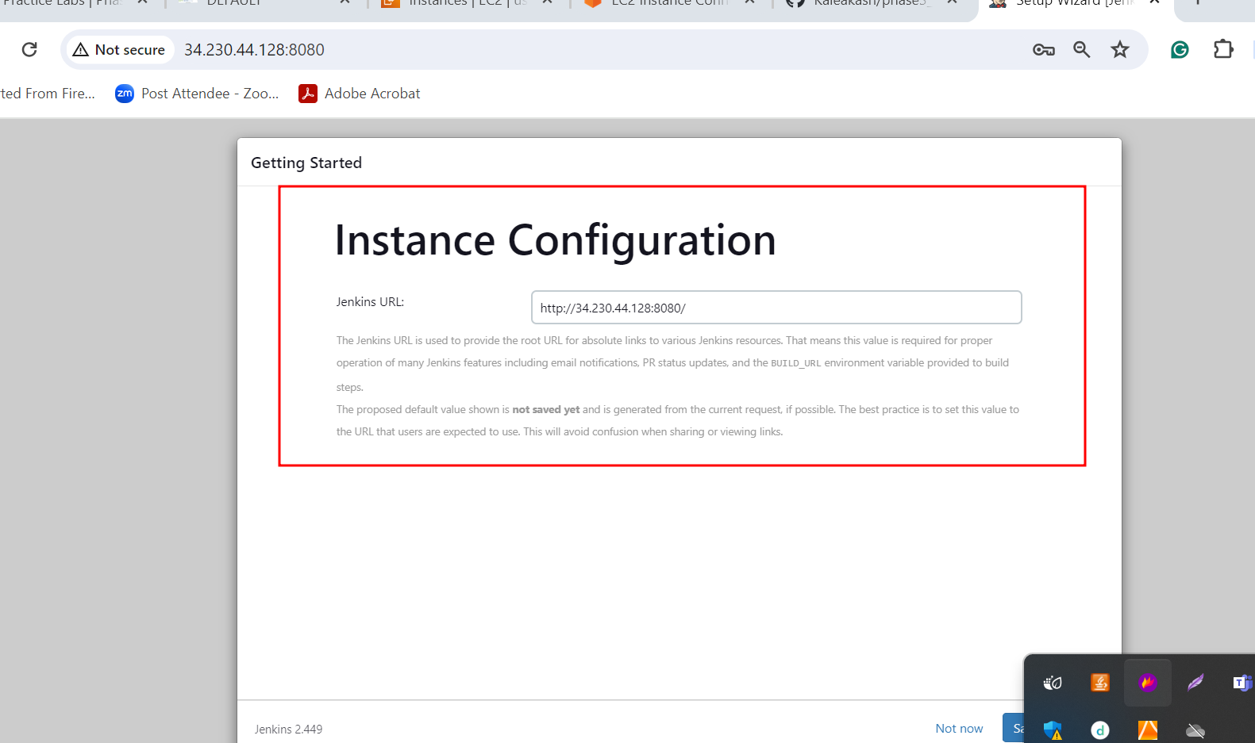

**5.10 : Now you need to install the Docker and Docker compose**

Below command install the docker

**sudo yum install docker**

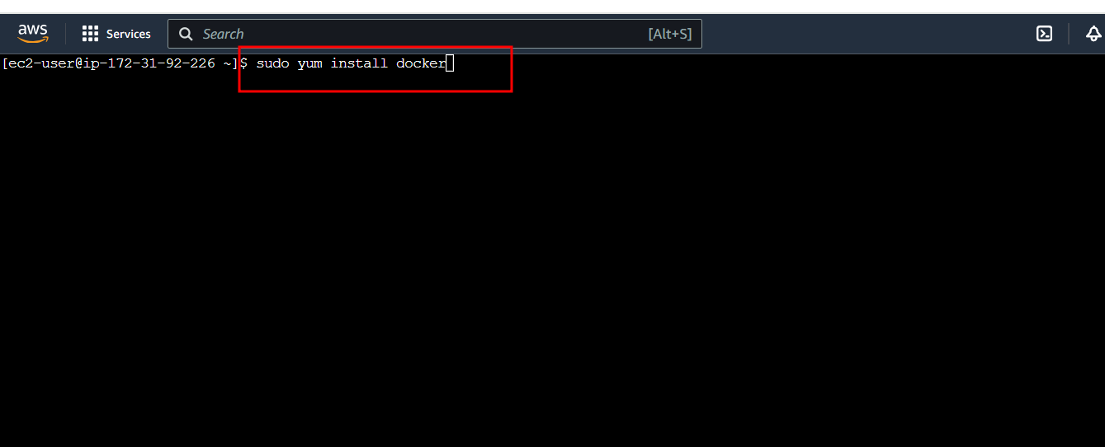

Below command start the docker service

**sudo service docker start**

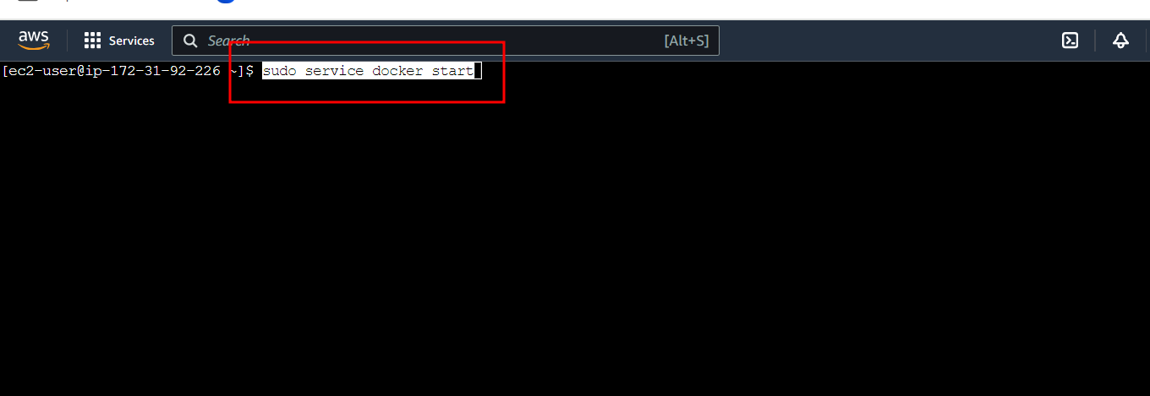

Below command check the status of the docker

**sudo docker info**

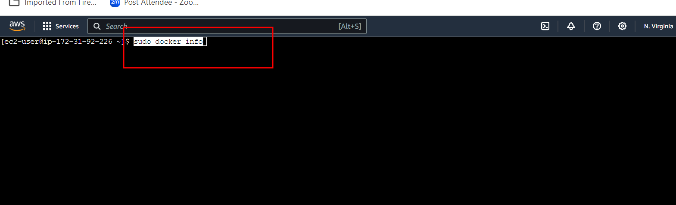

Download the current stable release of Docker Compose

**sudo curl -L https://github.com/docker/compose/releases/latest/download/docker-compose-$(uname -s)-$(uname -m) -o /usr/local/bin/docker-compose**

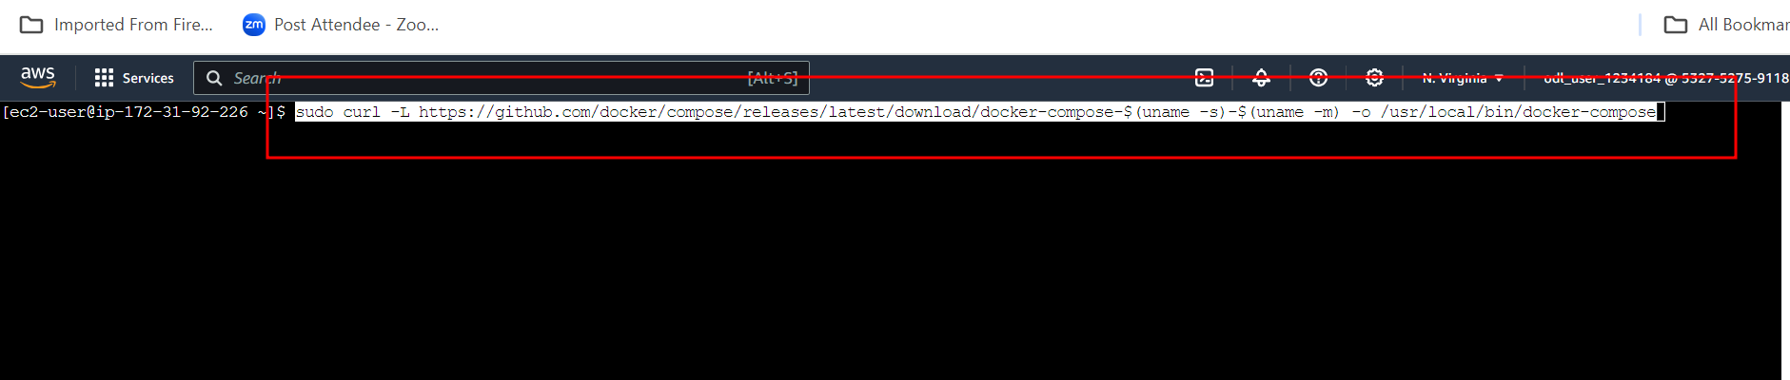

Give the permission

**sudo chmod +x /usr/local/bin/docker-compose**

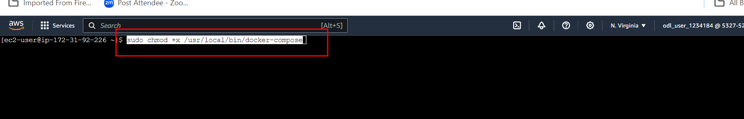

check the Docker version

**docker-compose version**

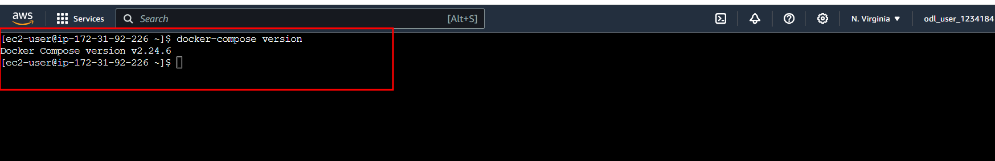

**5.11 :** Now we need create the group and add user, Jenkin and Docker to use the resource.

Create the docker group

**sudo groupadd docker**

Add docker and Jenkin in user mode

**sudo usermod -a -G docker jenkins**

Add docker and ec2 instance user

**sudo usermod -a -G docker ec2-user**

give the permission to run the docker in Jenkin environment.

**sudo chmod 777 /var/run/docker.sock**

restart the Jenkin

**sudo service jenkins restart**

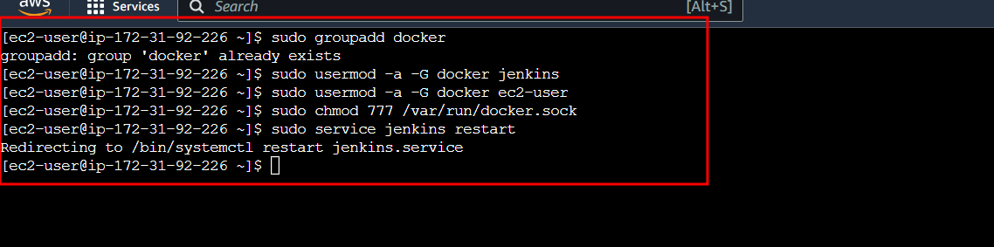

**Step 6 : Now login the Jekin dashboard**

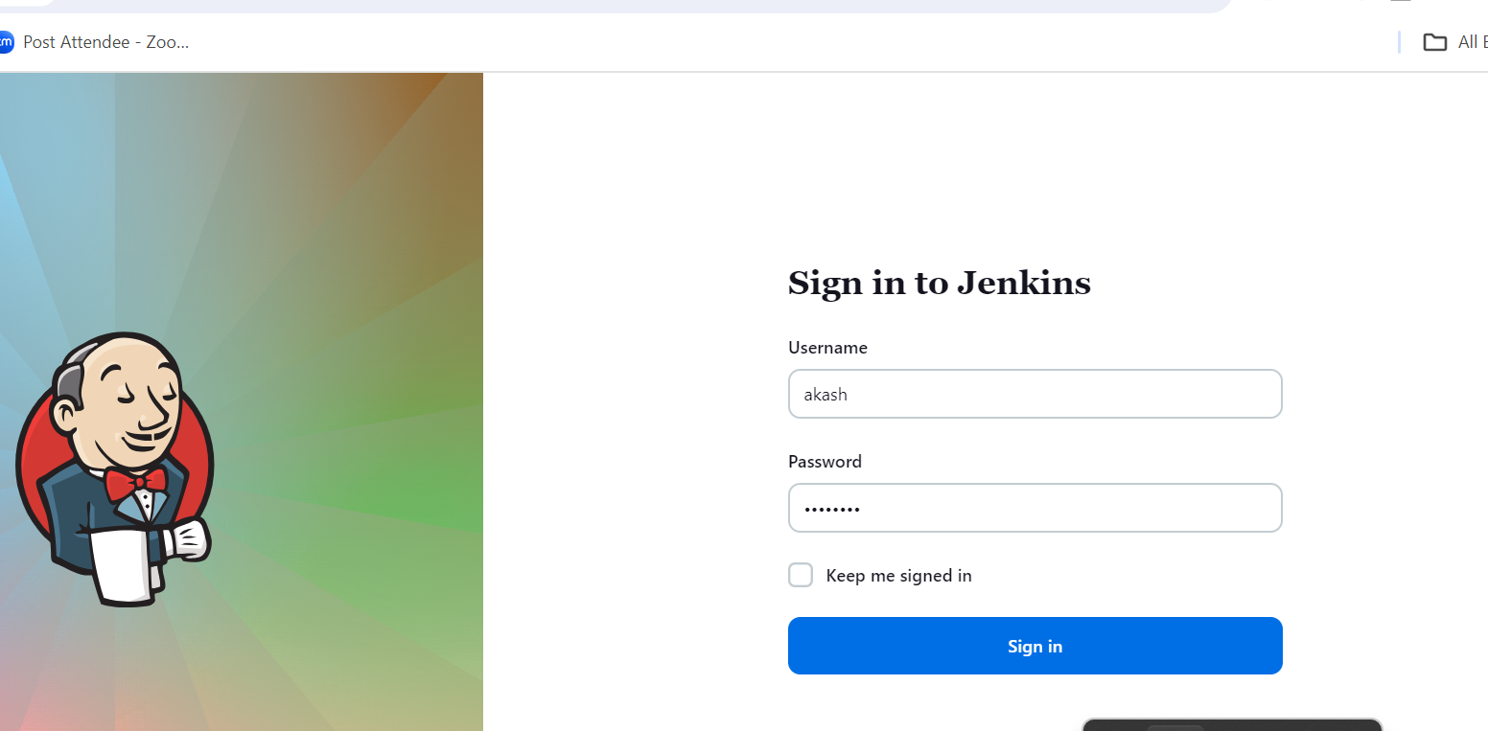

**6.1 Now you need to create the Jenkin job.**

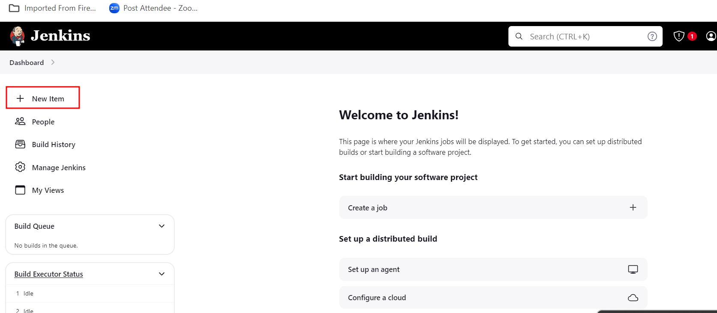

**6.2 Now you need to create the Jenkin job**

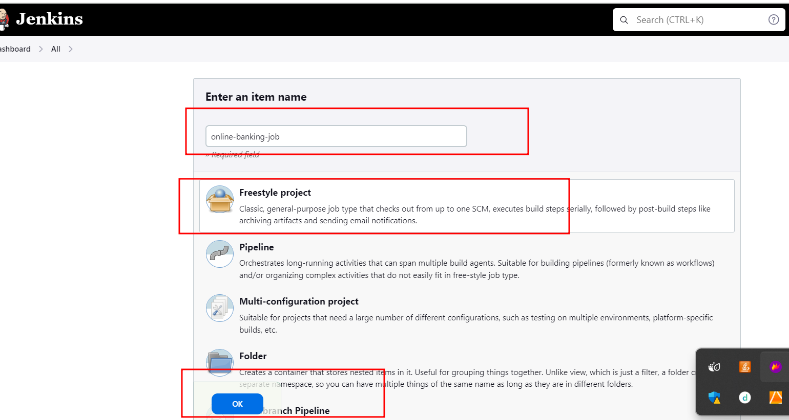

**6.3 General option in job**

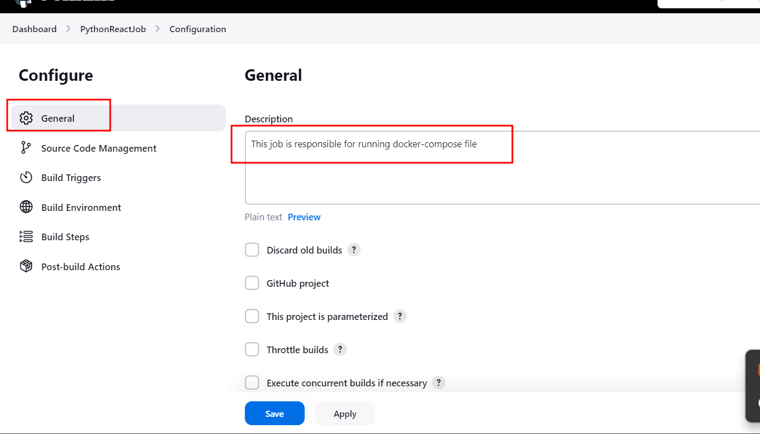

**6.4 In Source code management, please select the git option. Provide the Git reposit URL and provide the branch name ie may be master or main.**

[**https://github.com/Kaleakash/phase3_online-banking-test.git**](https://github.com/Kaleakash/phase3_online-banking-test.git) **(please provide your updated remote repository URL with your EC2 instance Ip Address)**

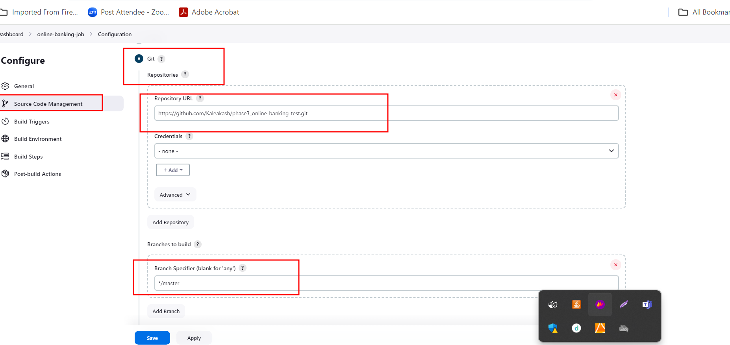

**If master please change to master.**

**6.5 Build trigger option. Poll SCM with * * * * *. So Jenkin check with every minute any changes happen in git hub account if any changes it will build the job.**

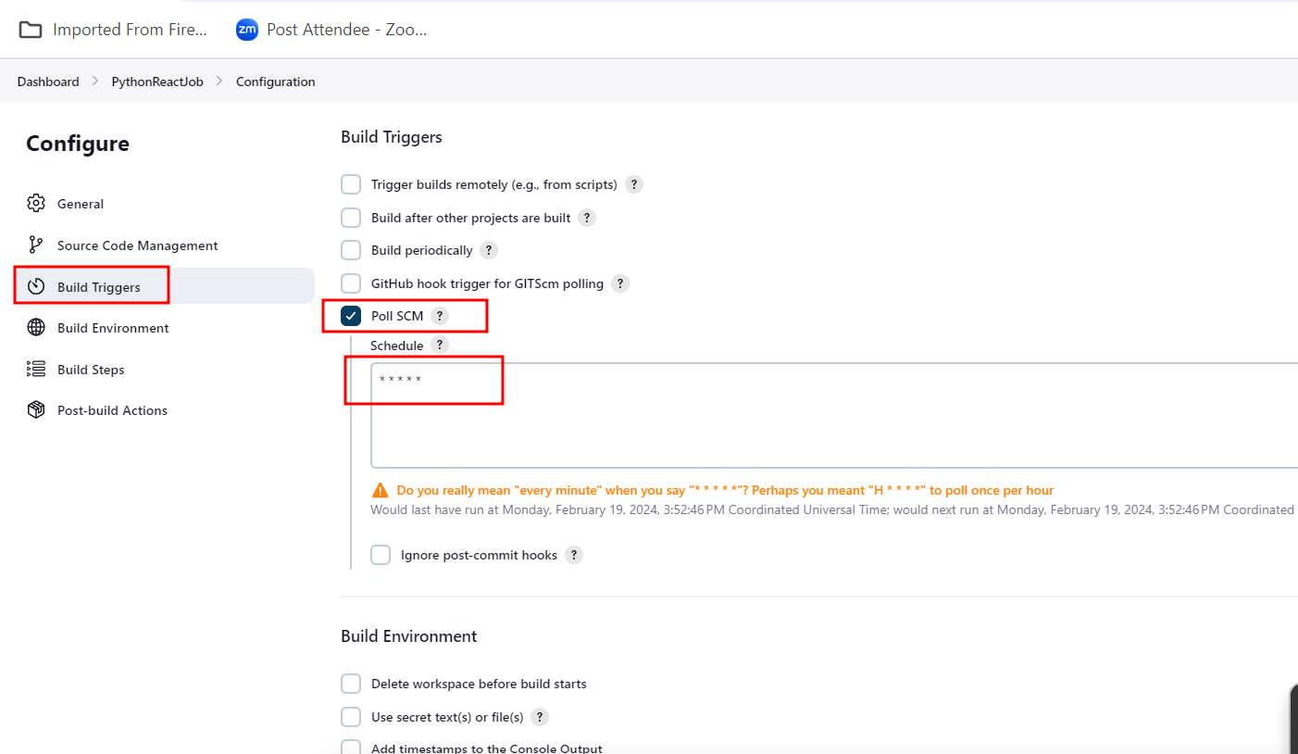

**6.6 In Build option we can write the command to run the docker compose file which is responsible to run three container as well as we can verify image and container details.**

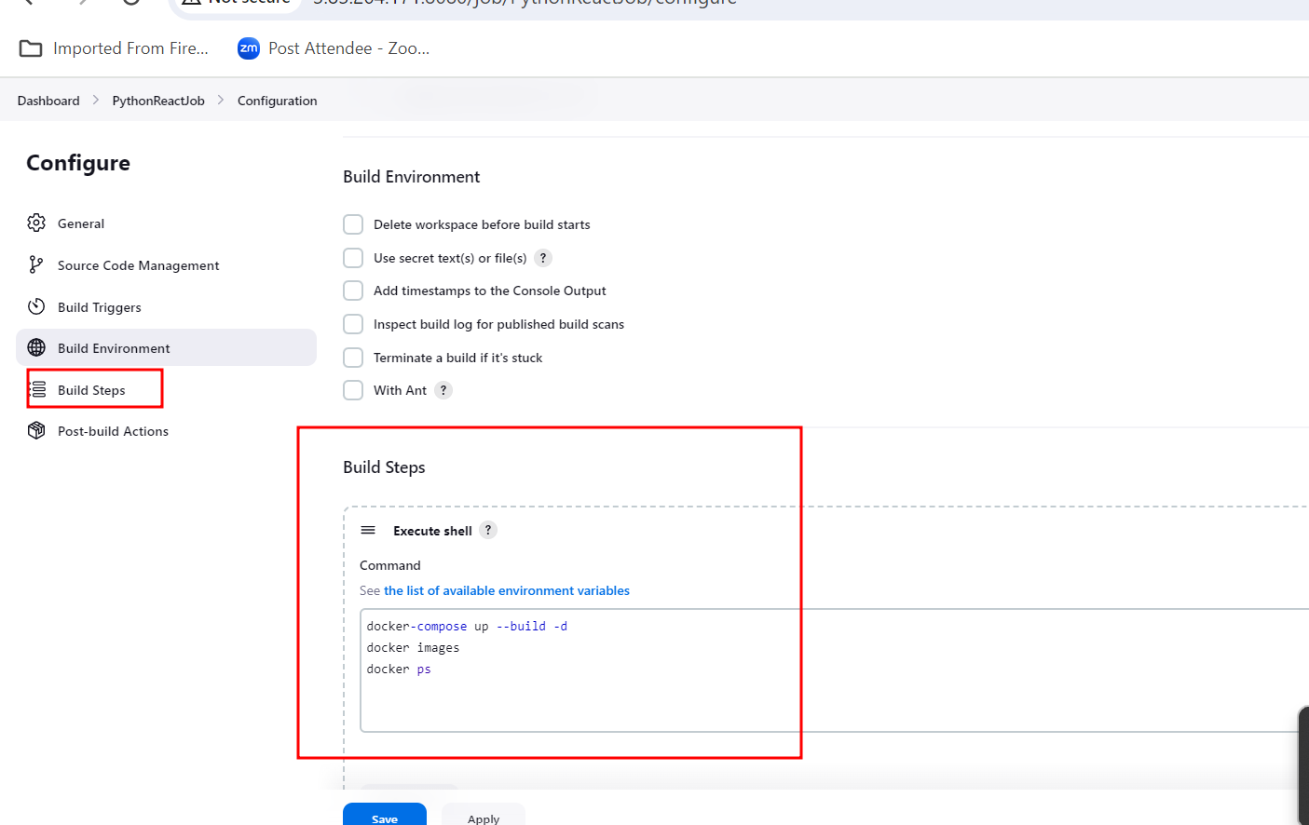

**6.7 : Now you can save and build the projects.**

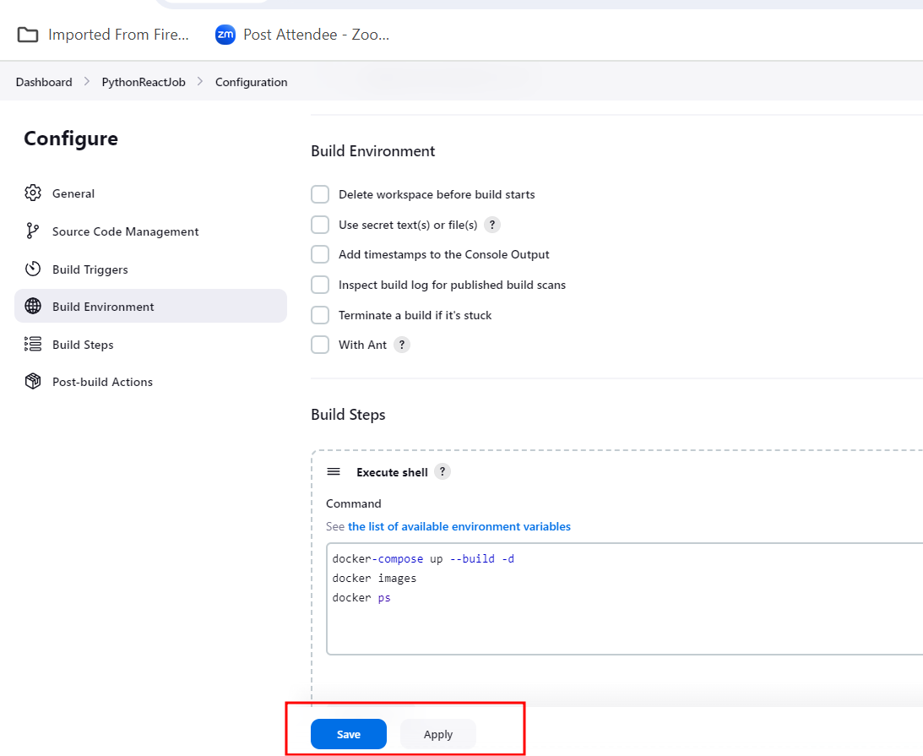

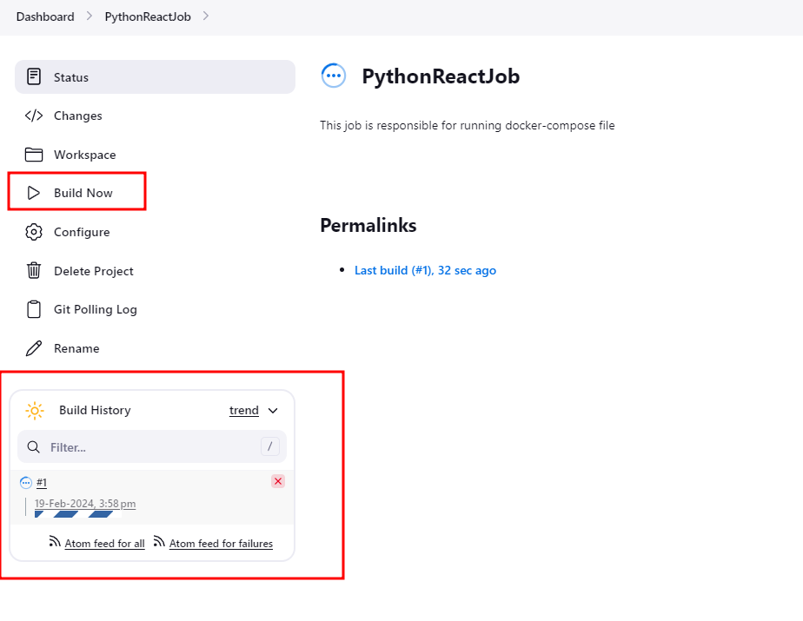

**It take time it pull project then create the image and run the container.**

**6.8 : you can check the build status.**

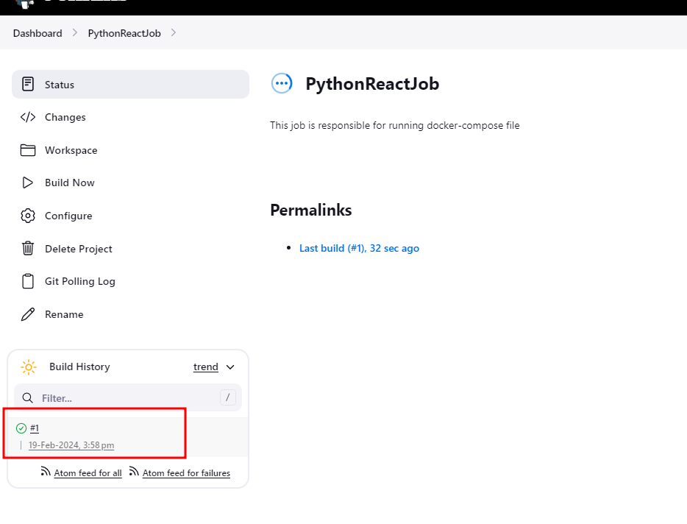

**5.12 Now click on success status and open the console**

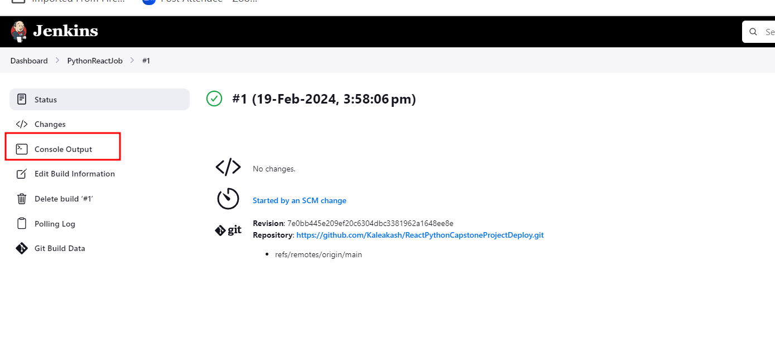

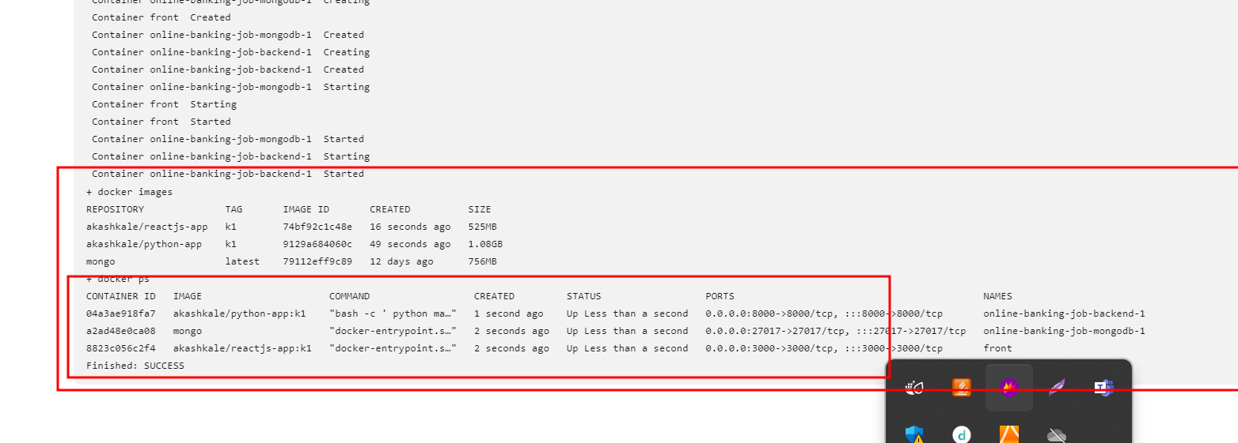

**5.13 Now open EC2 instance terminal**

**Run the command as docker ps to check the running containers.**

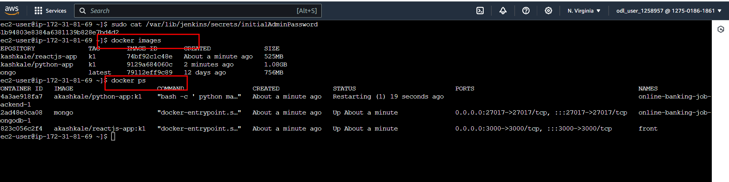

**If any issue in docker**

**Please remove all docker container using below command in EC2 instance terminal**

**docker rm containerId -f**

**then later on remove all images, network and other resources using below command**

**docker system prune -a**

**and then re-try**

**6. Test the application**

**6.1 Now you need to create the Django admin account.**

**Please move inside a backend folder which is part of project folder.**

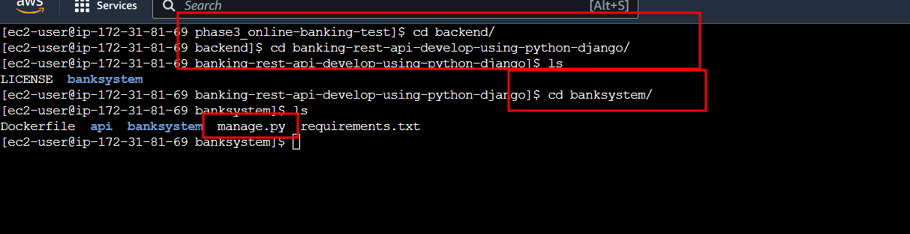

**Make sure you are inside a that folder. There manage.py file must be present.**

**Now you need to move inside a Django – container shell.**

**docker ps it show all running container**

**docker exec -it phase3_online-banking-test-backend-1 python manage.py shell**

**it open python-django container shell**

**phase3_online-banking-test-backend-1 this is your container name please verify it. If any other name please change it.**

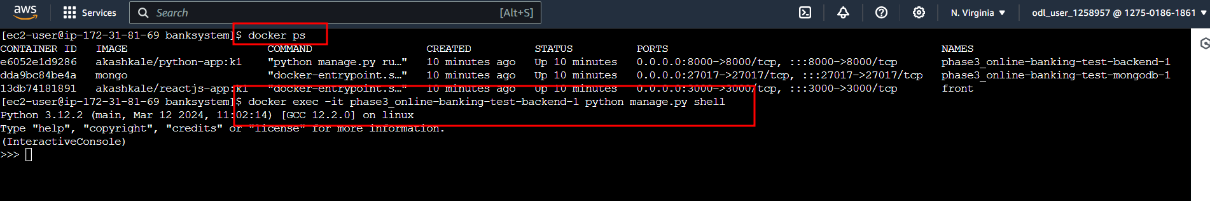

**Then you need to execute the below command to create the admin account.**

**from django.contrib.auth import get_user_model; User = get_user_model(); User.objects.create_superuser('admin', 'admin@myproject.com', 'password')**

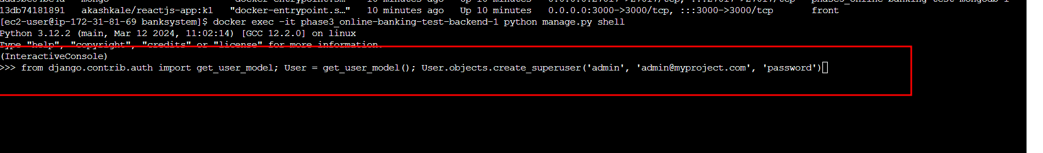

**Here username is admin and password is password itself.**

**Now using your EC2 instance public id address with port number 8000 open the below command**

[**http://publicIPAddress:8000/admin**](http://publicIPAddress:8000/admin)

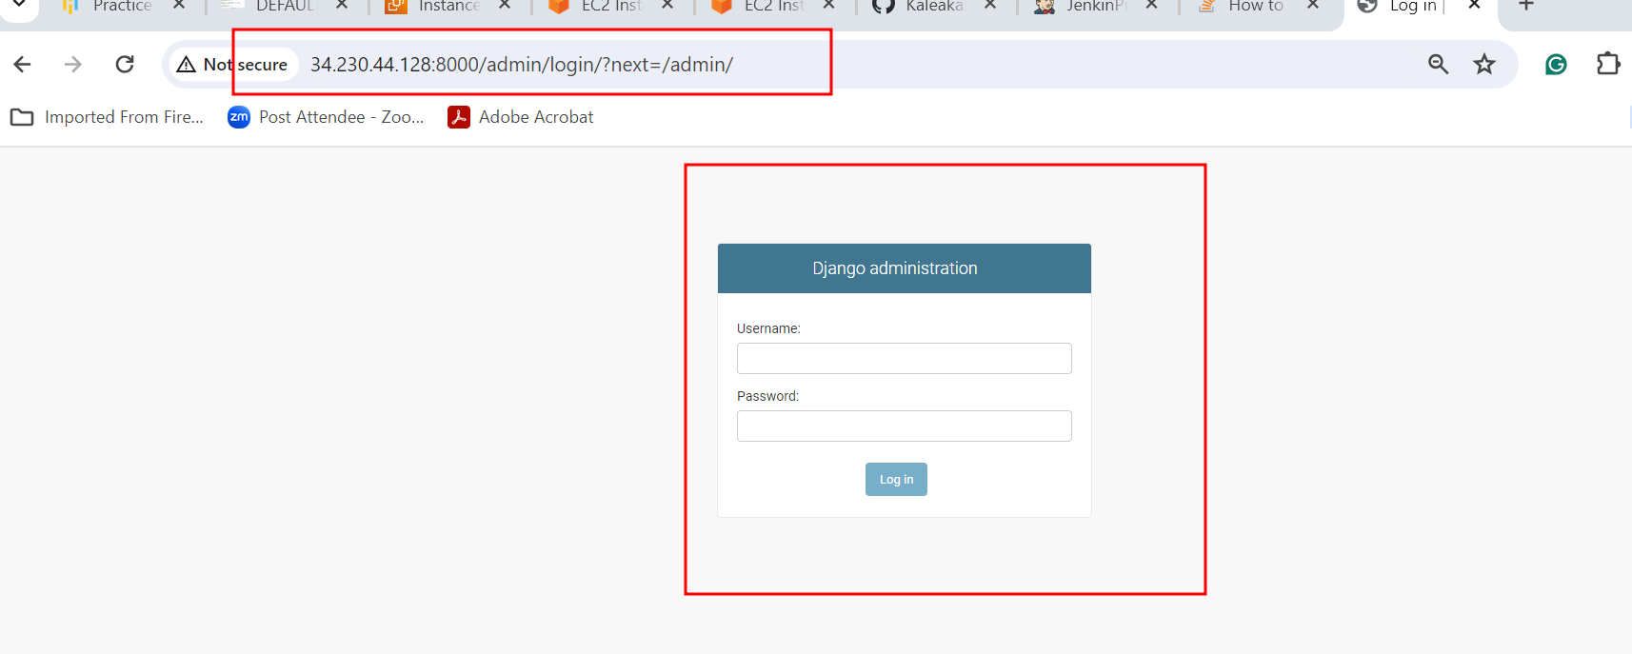

**Username is admin**

**Password is password**

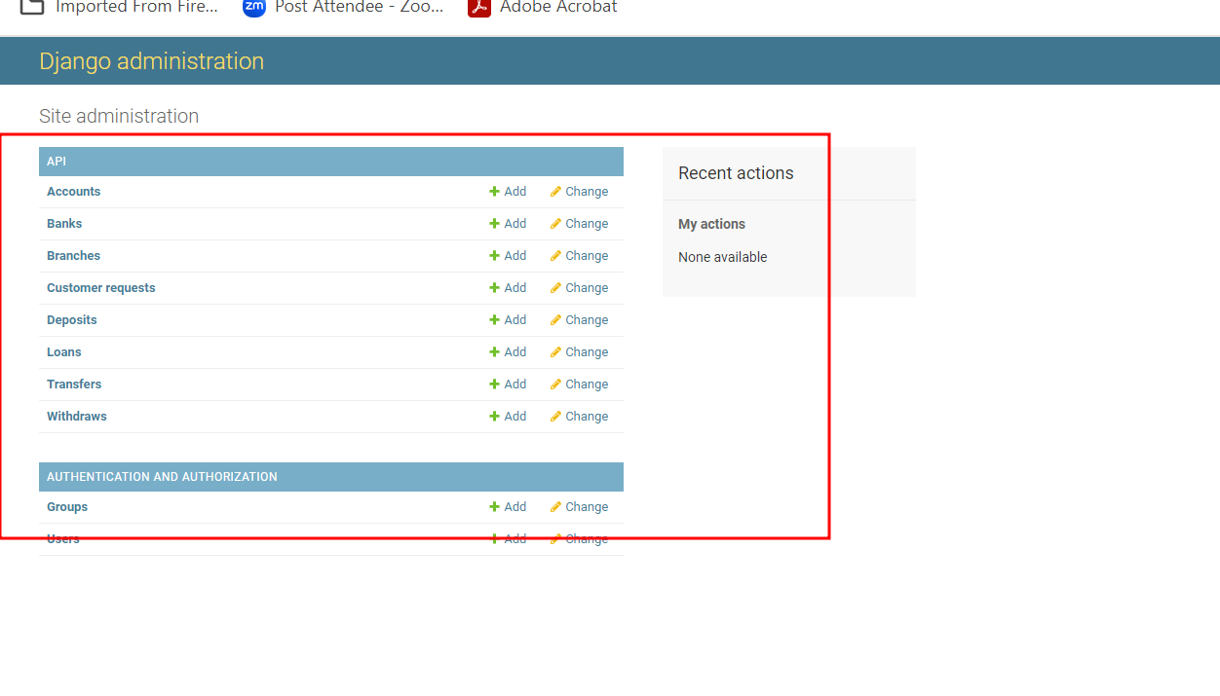

**Now you will create the Branch**

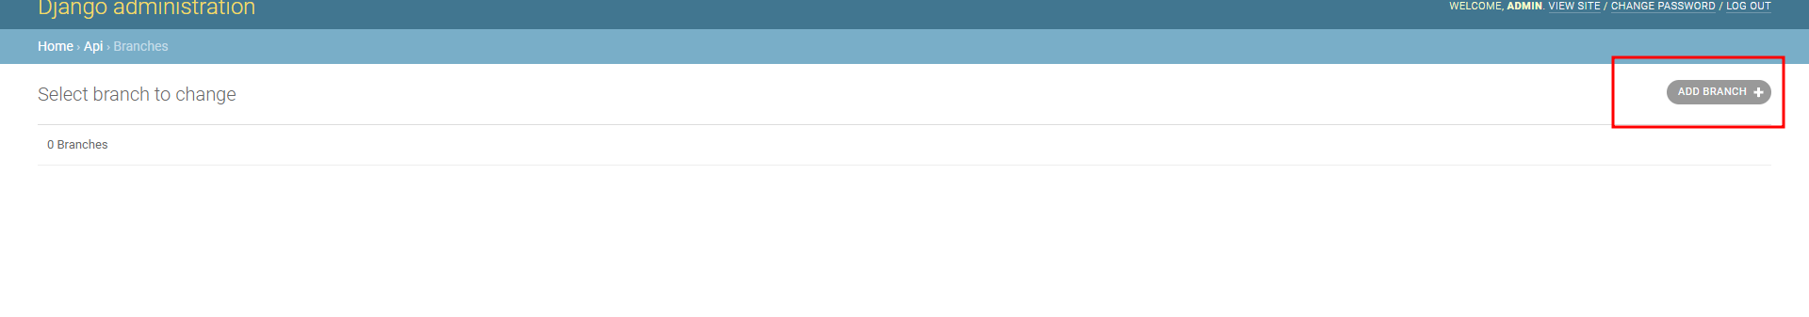

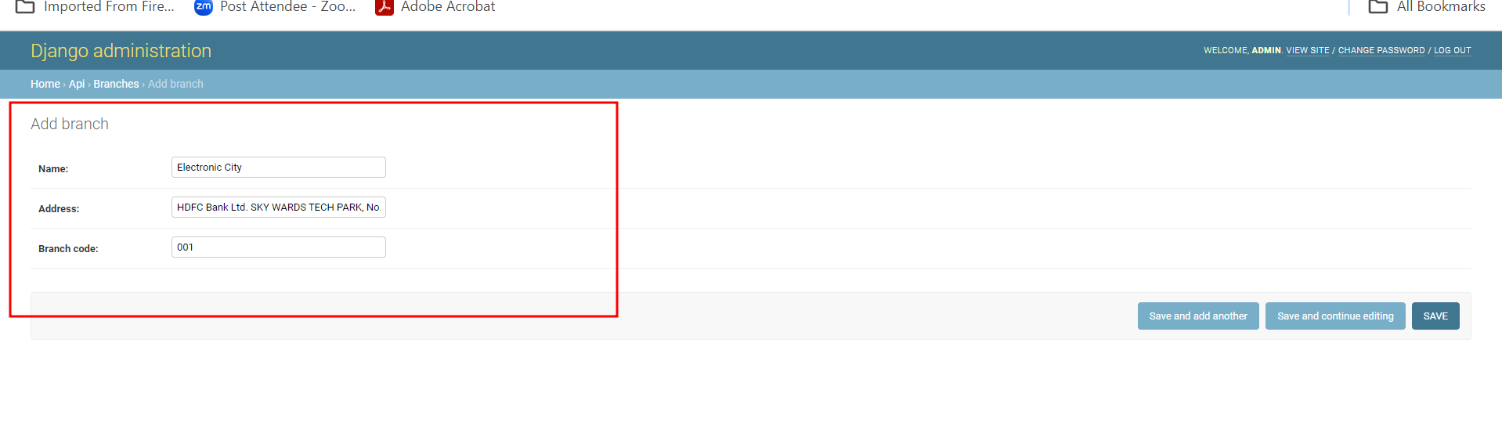

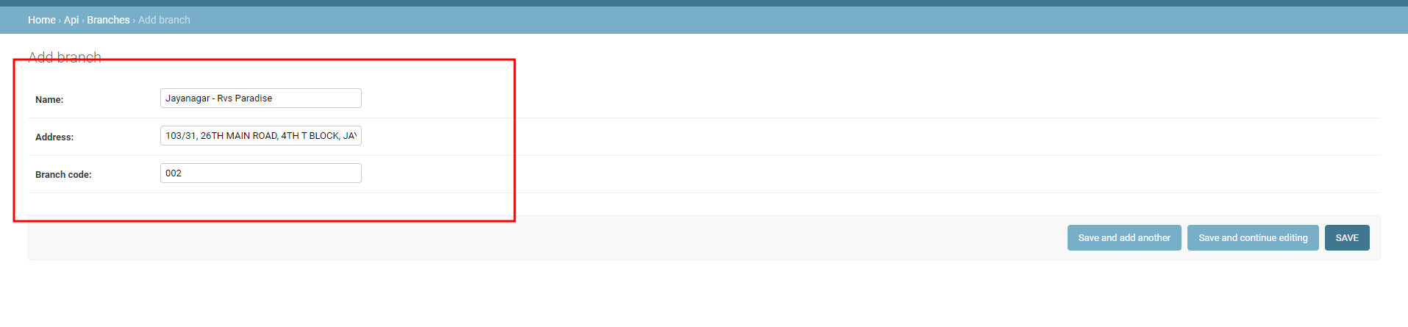

**After added few branches**

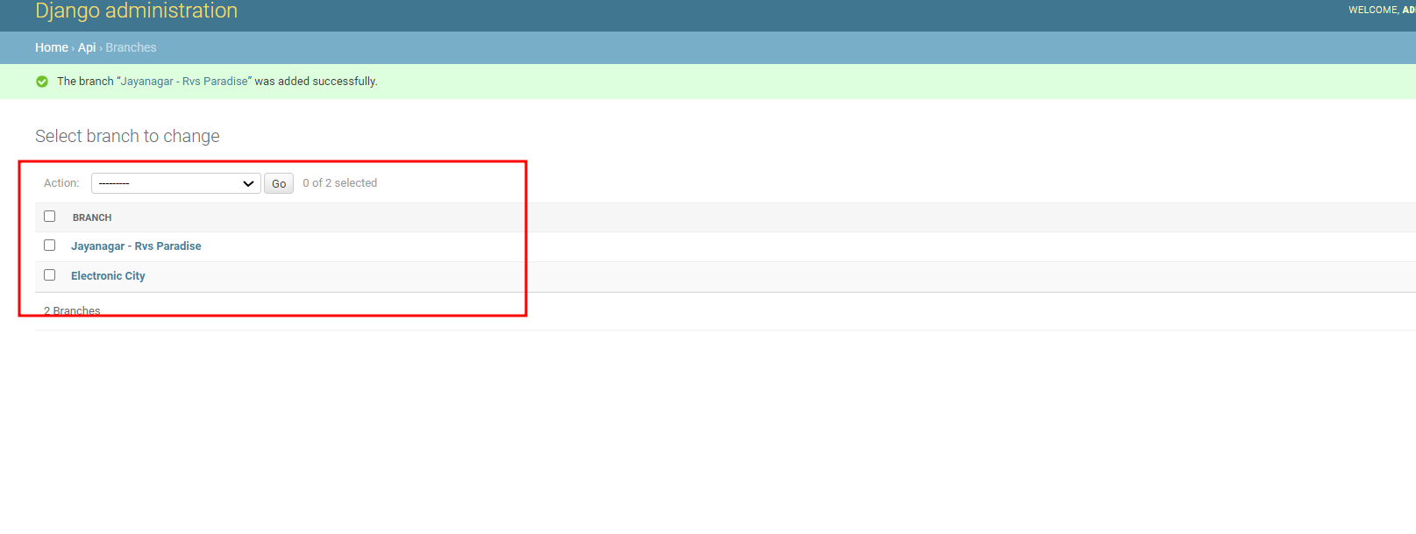

**Now we will add Bank Details.**

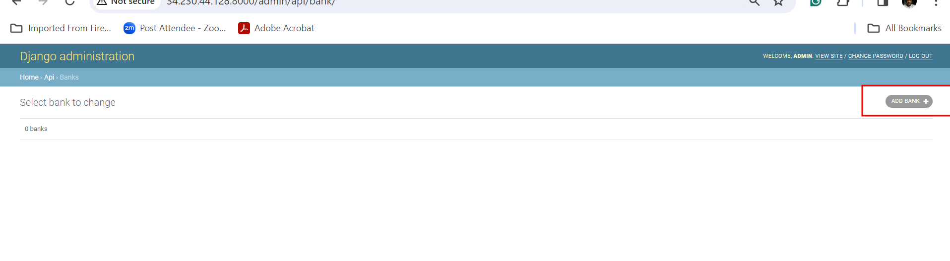

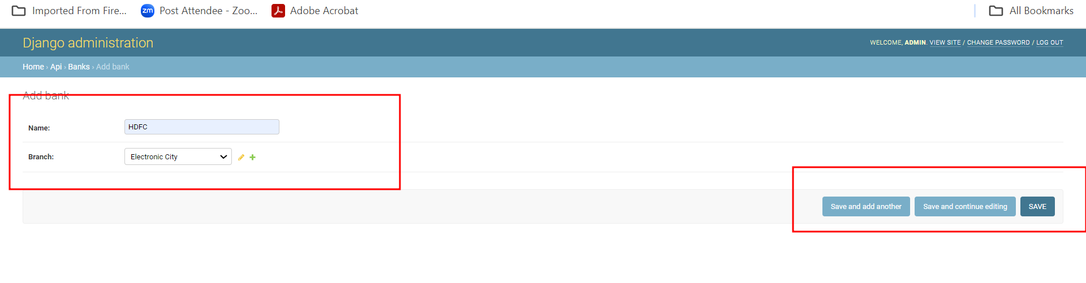

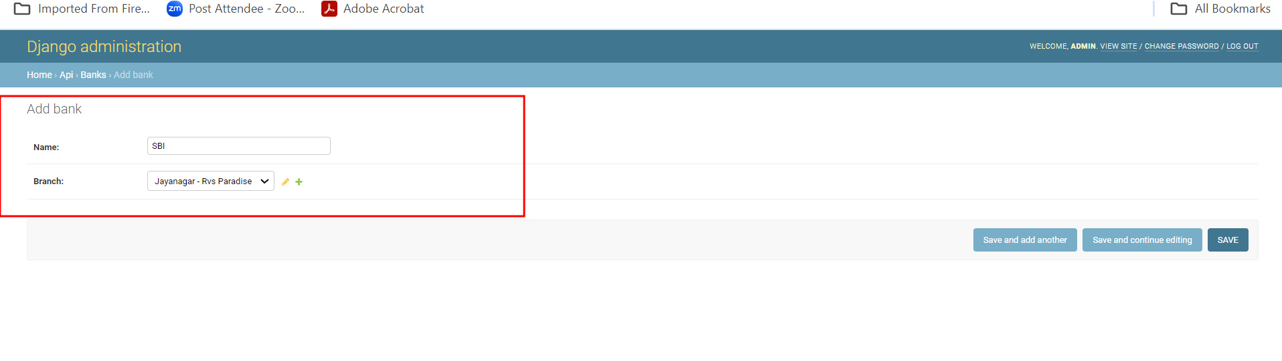

**Here we added two banks details.**

**Now you can open your frontend technologies using below URL as**

[**http://publicIdAddress:3000**](http://publicIdAddress:3000)

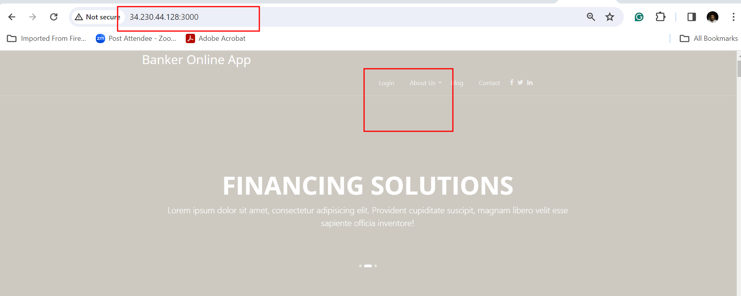

**Now we will do the signup**

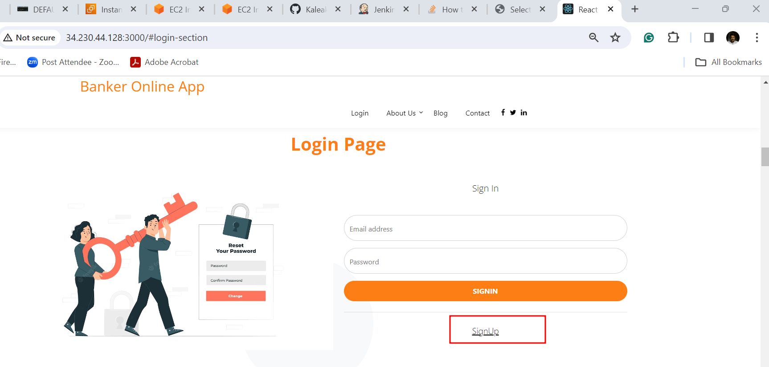

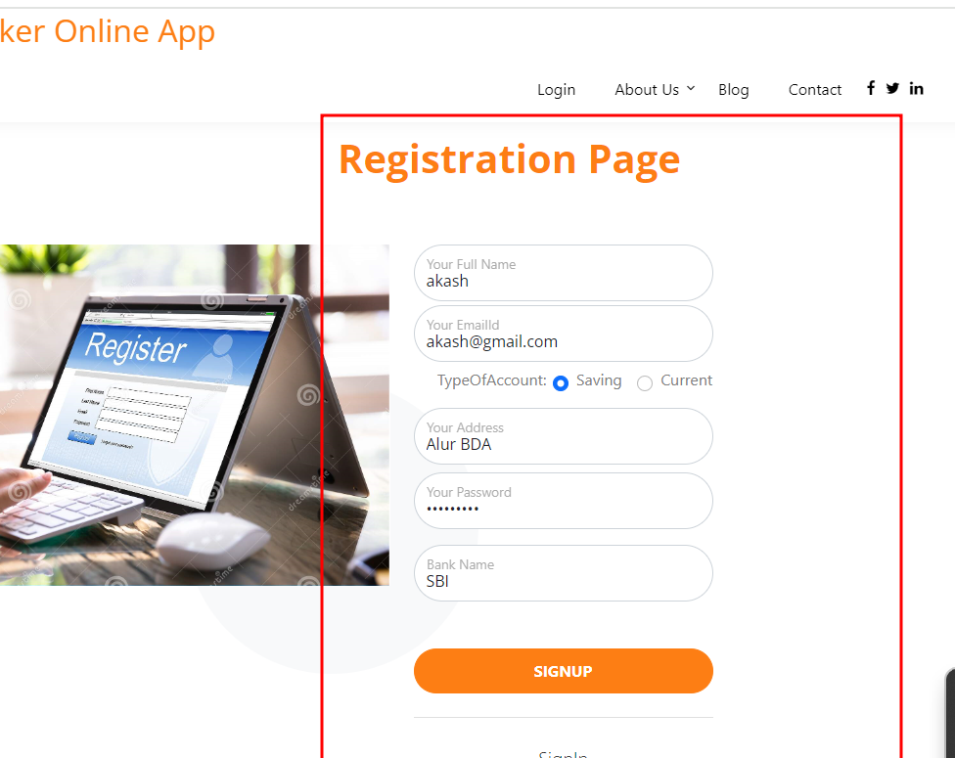

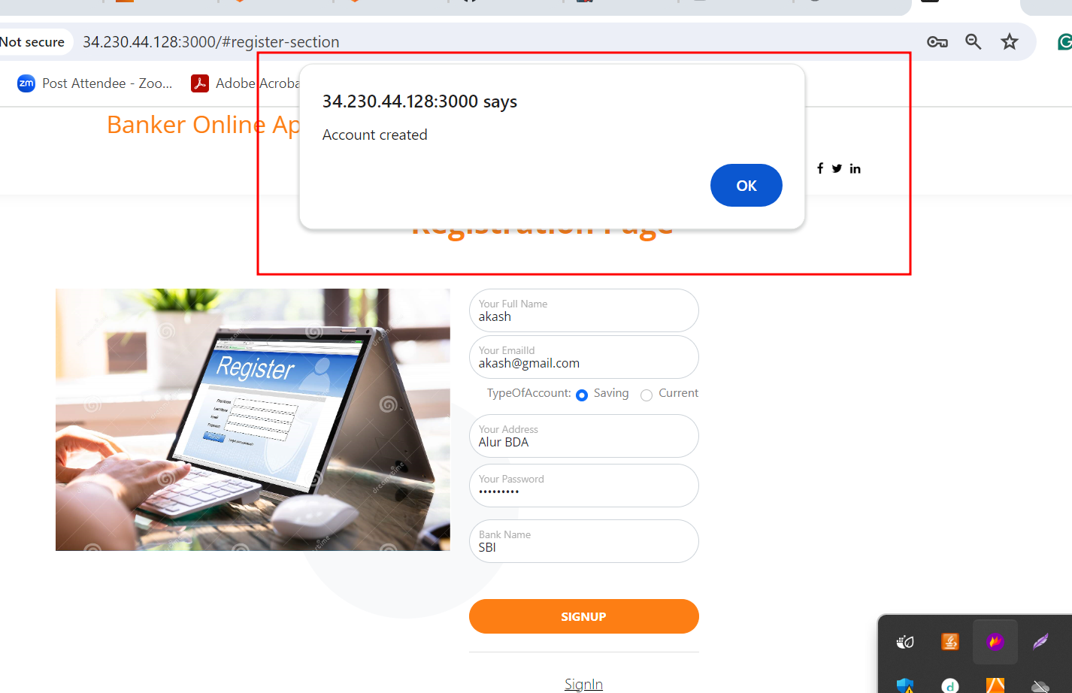

**After account created successfully no you can do the signin**

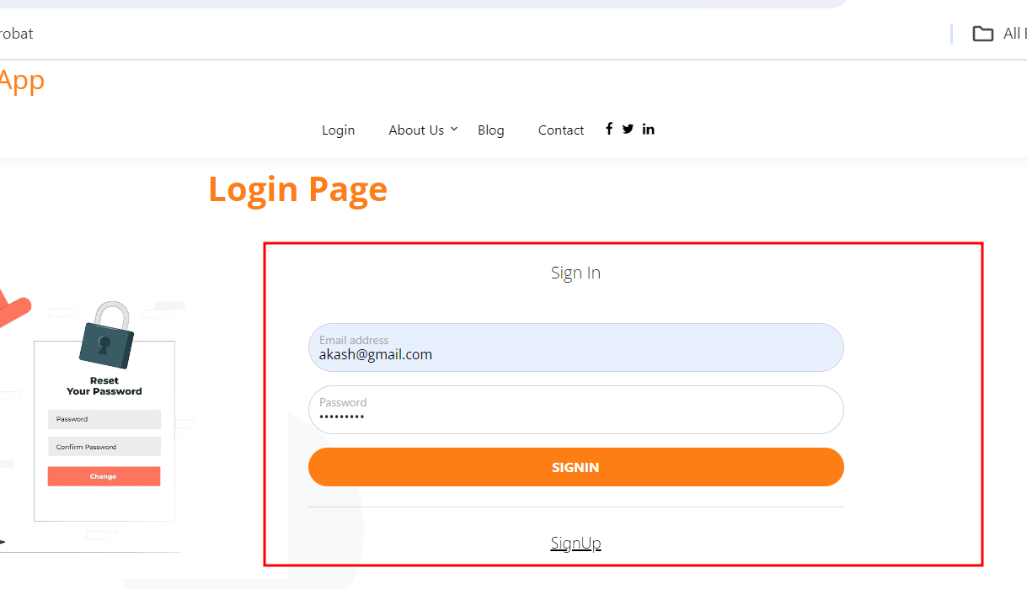

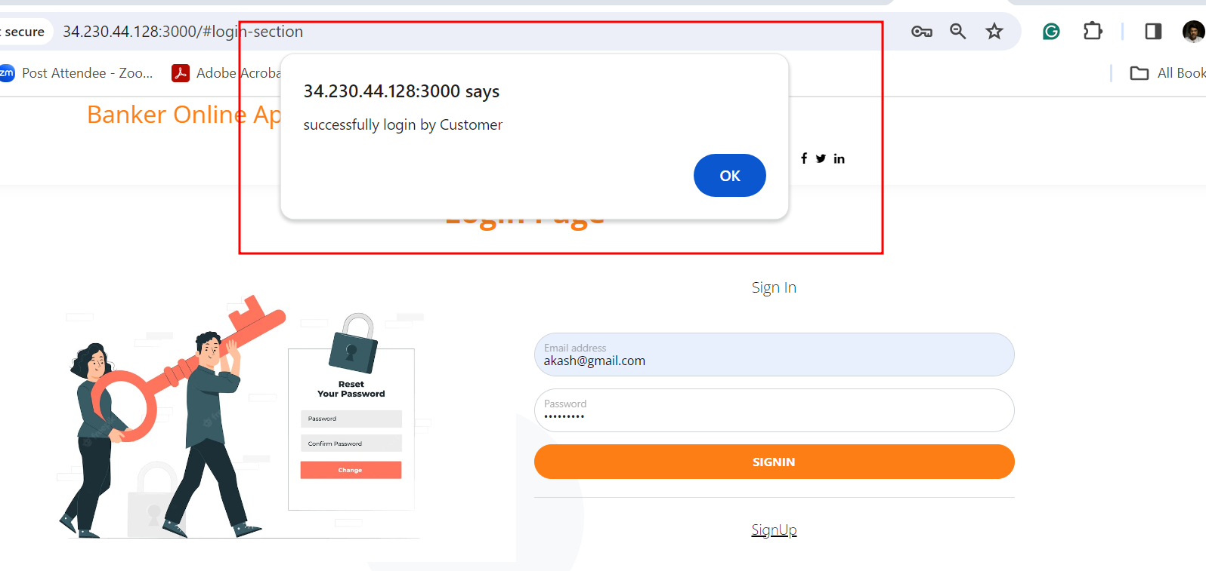

**If some time if page taking more time to get the dashboard please refresh the page it will open.**

**View your account details**

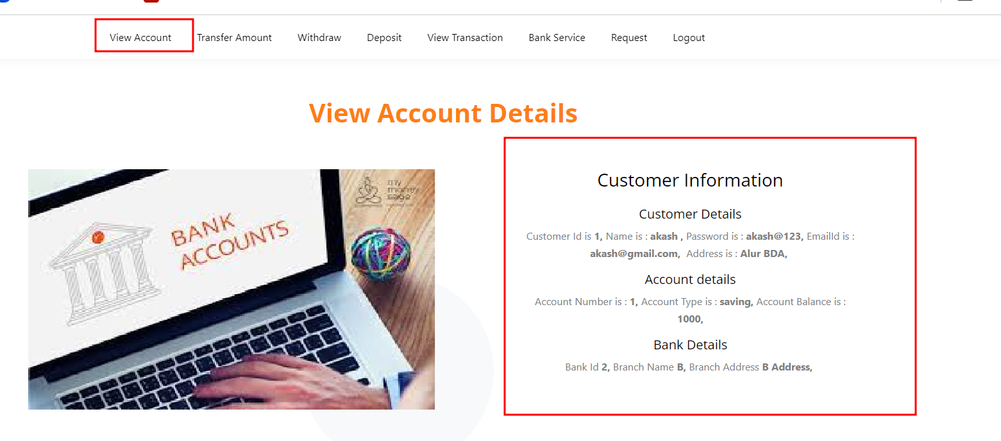

**Withdrawn the amount**

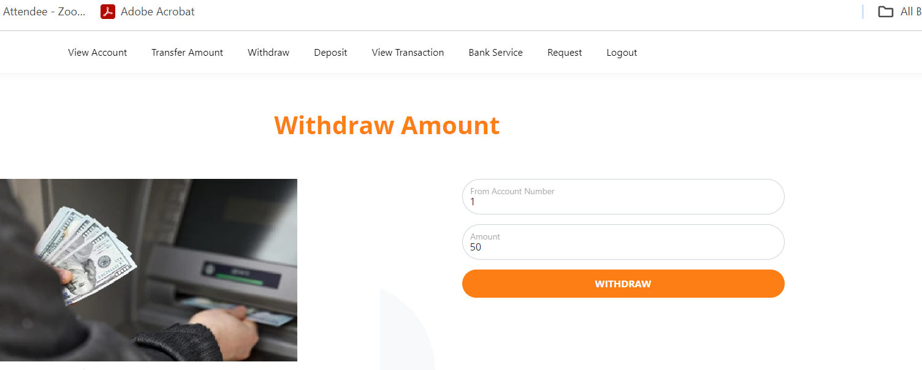

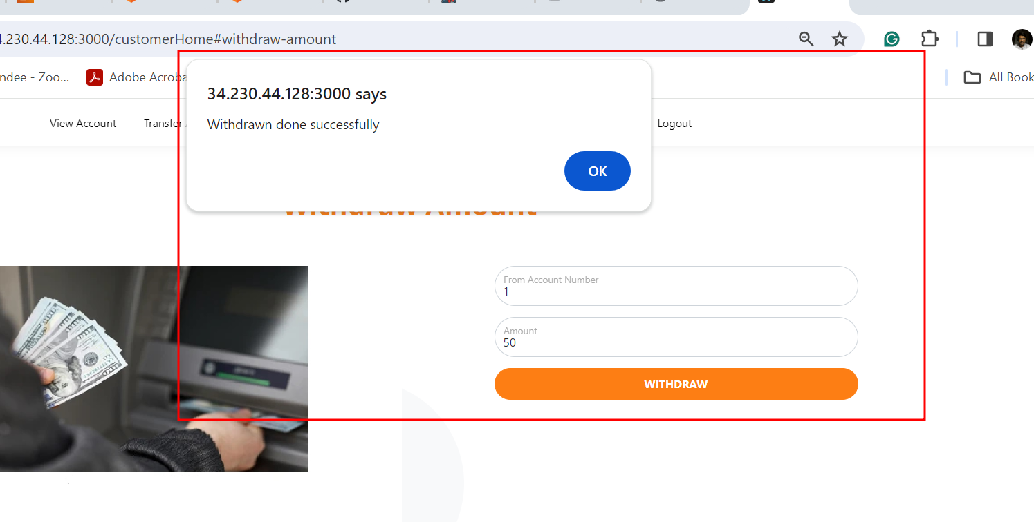

**Deposit the amount**

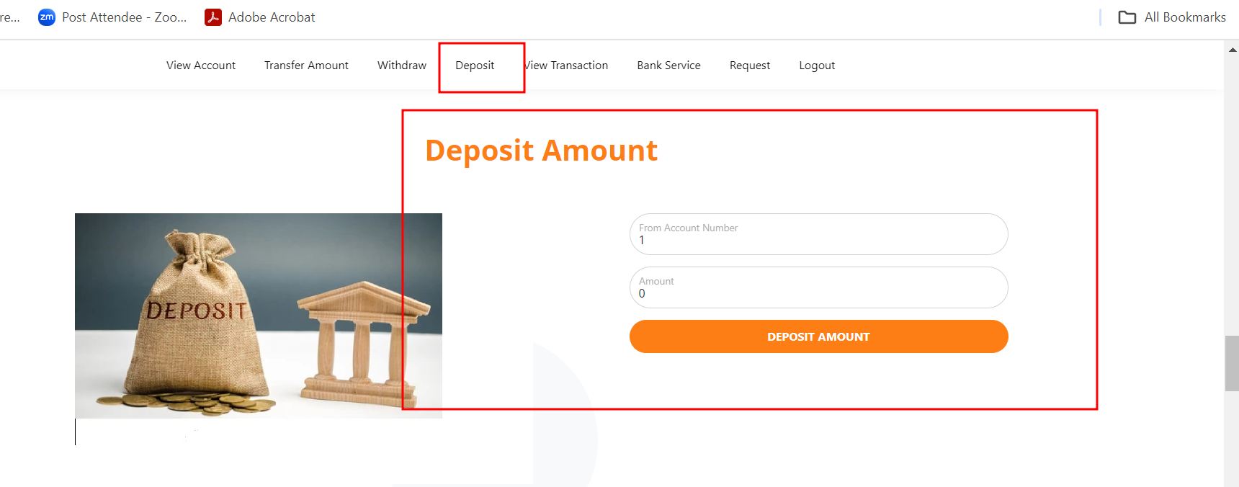

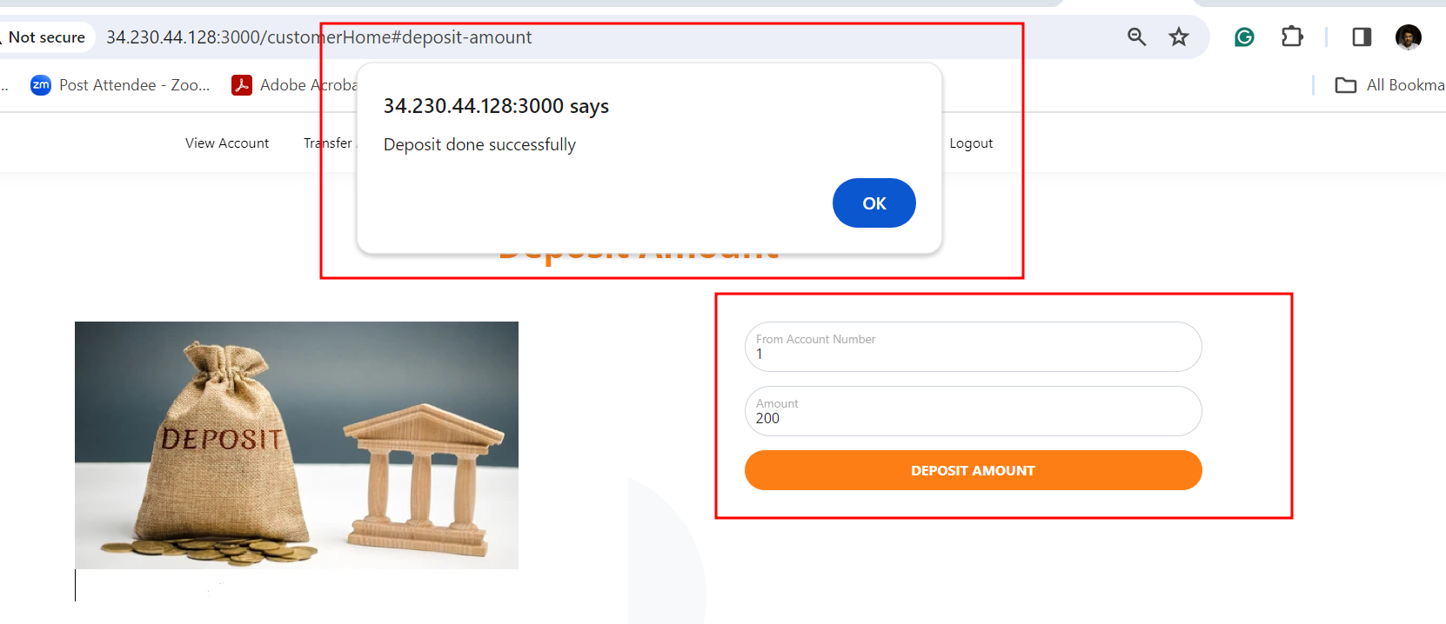

**Check the transaction details.**

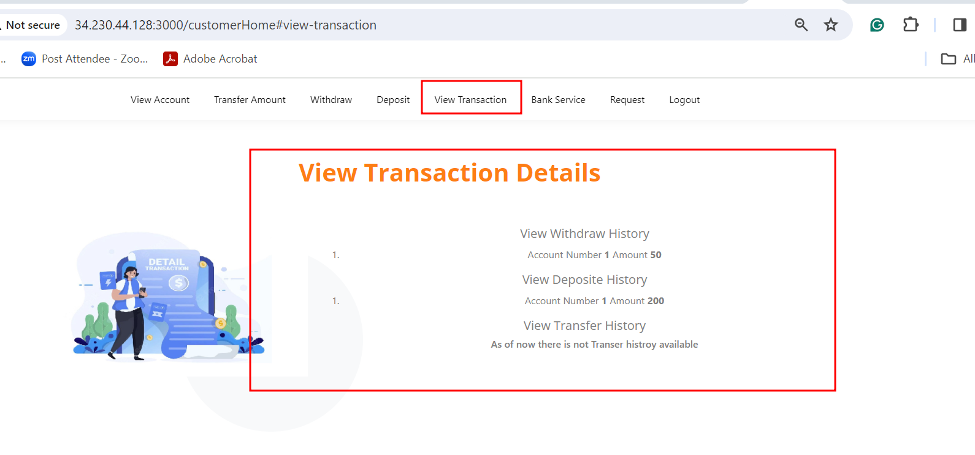

**Request for any service**

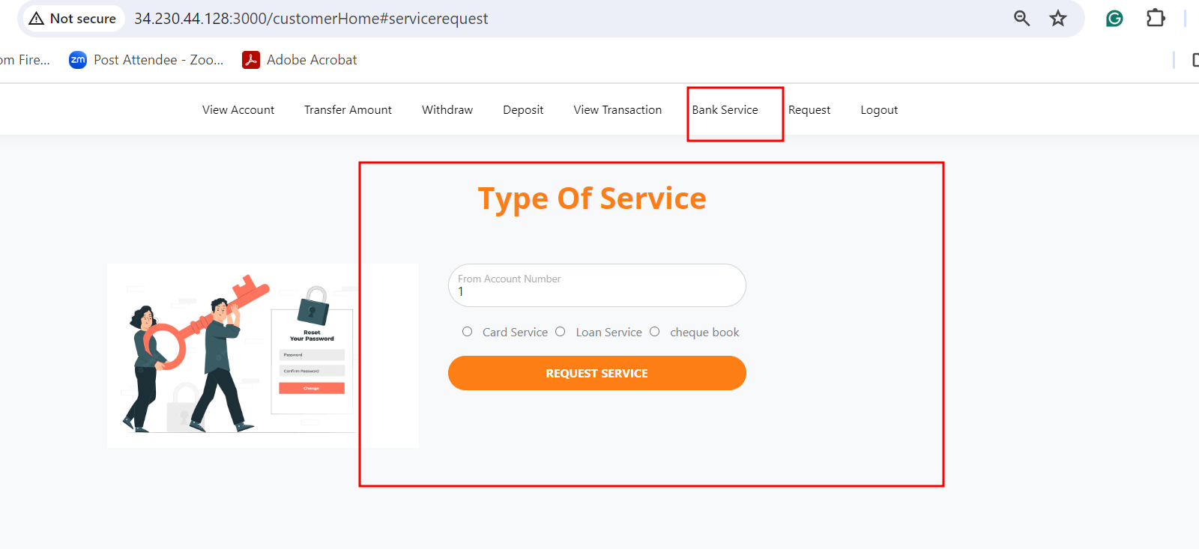

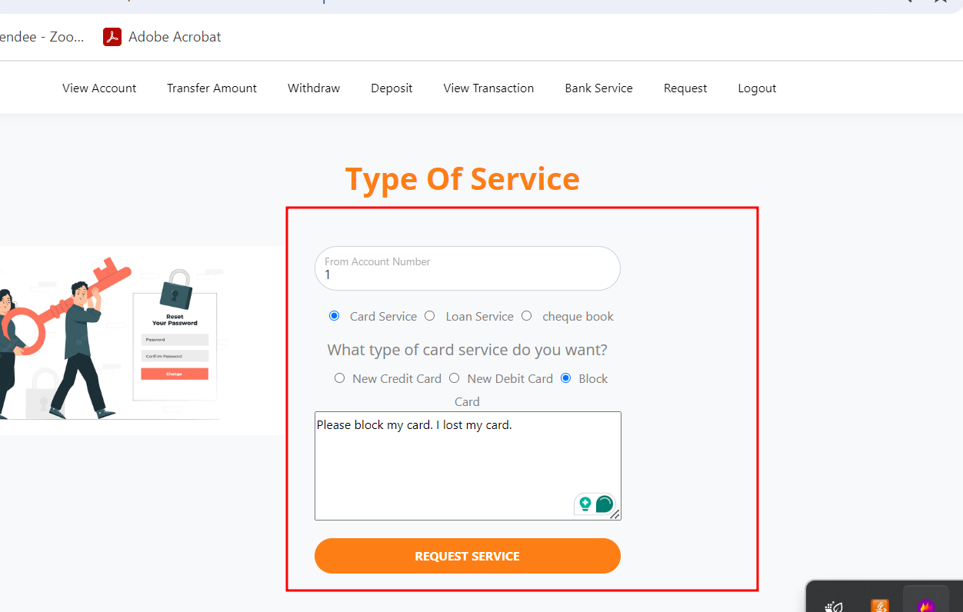

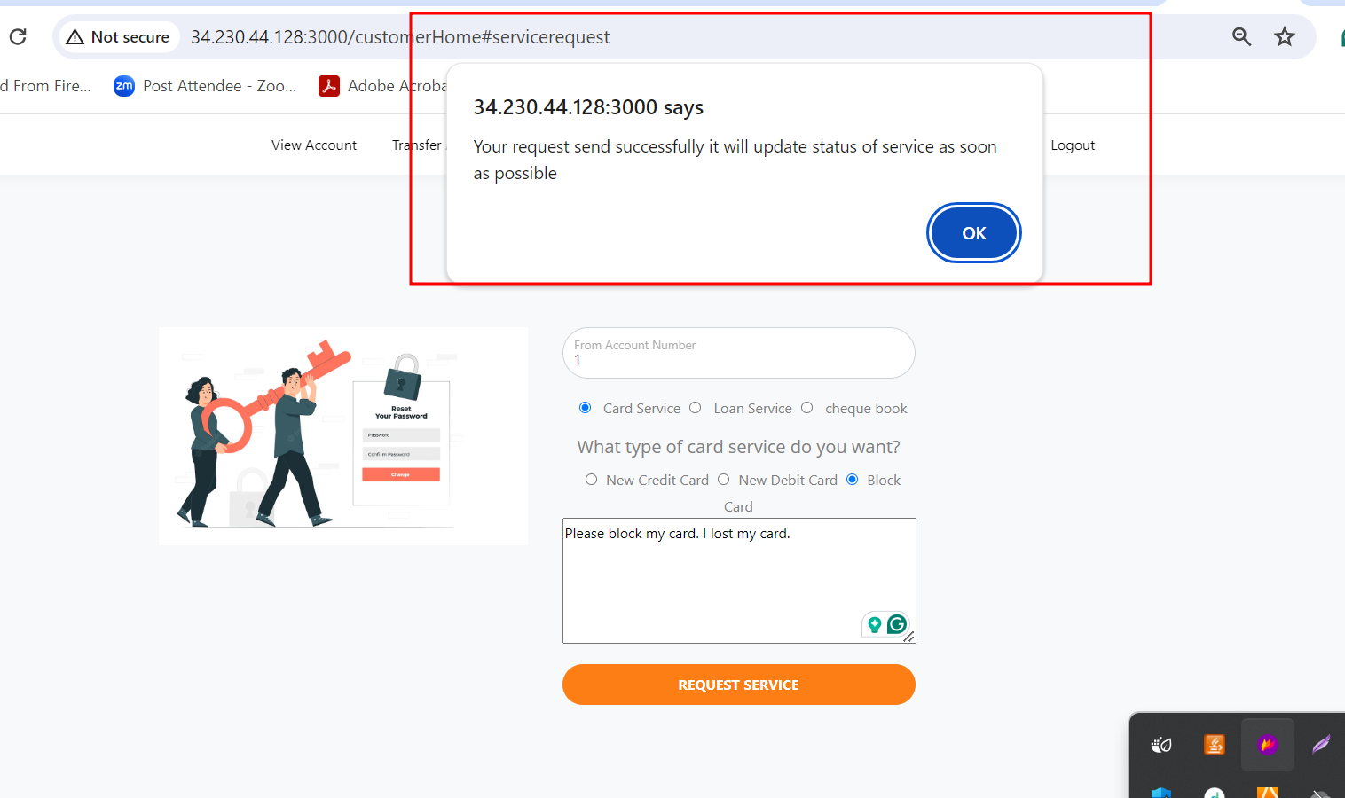

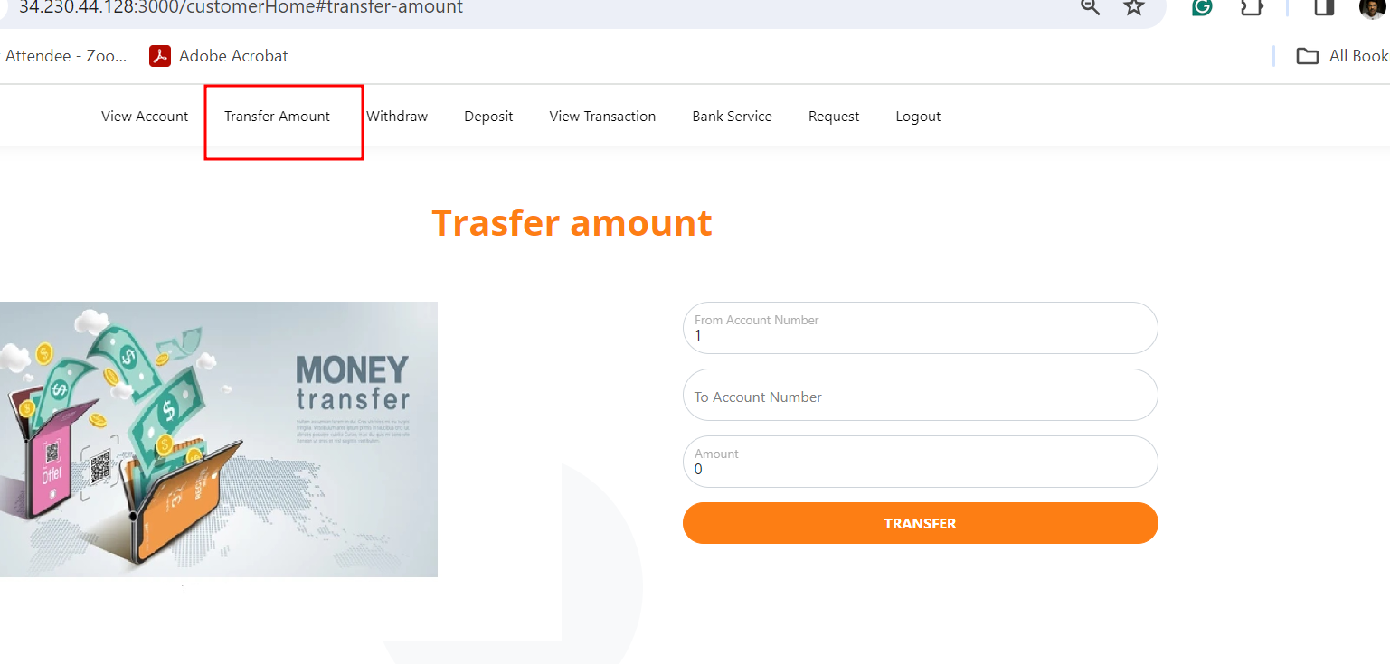

**You can create another account and transfer for that account for testing purpose.**

**So whatever task you done all work you can see the admin dashboard**

**Check account detail**

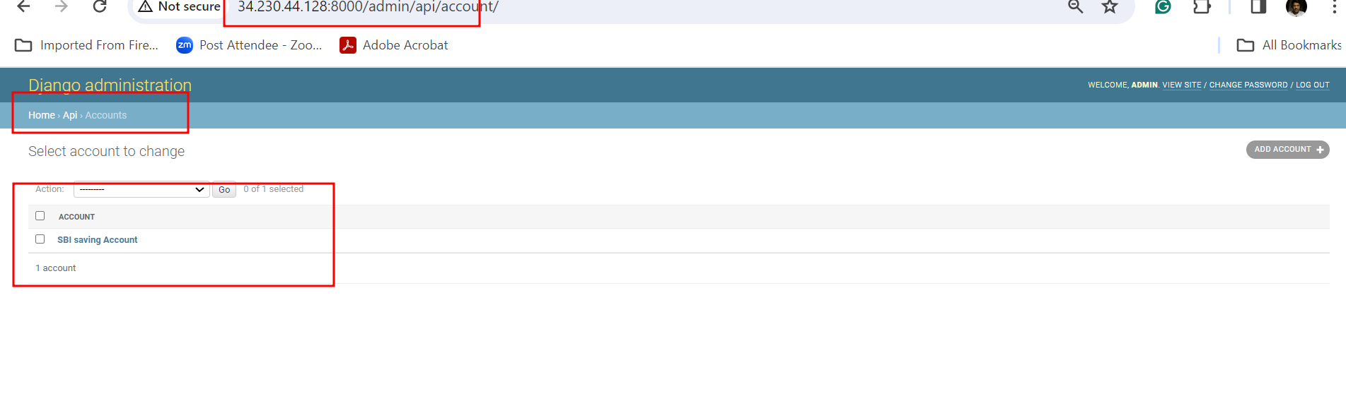

**Check withdraw details**

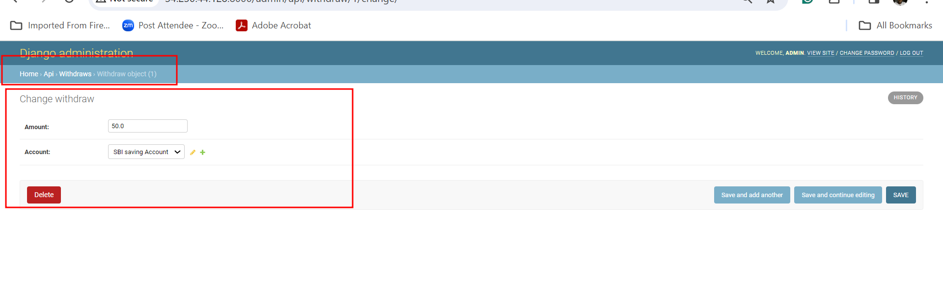

**Check deposit details**

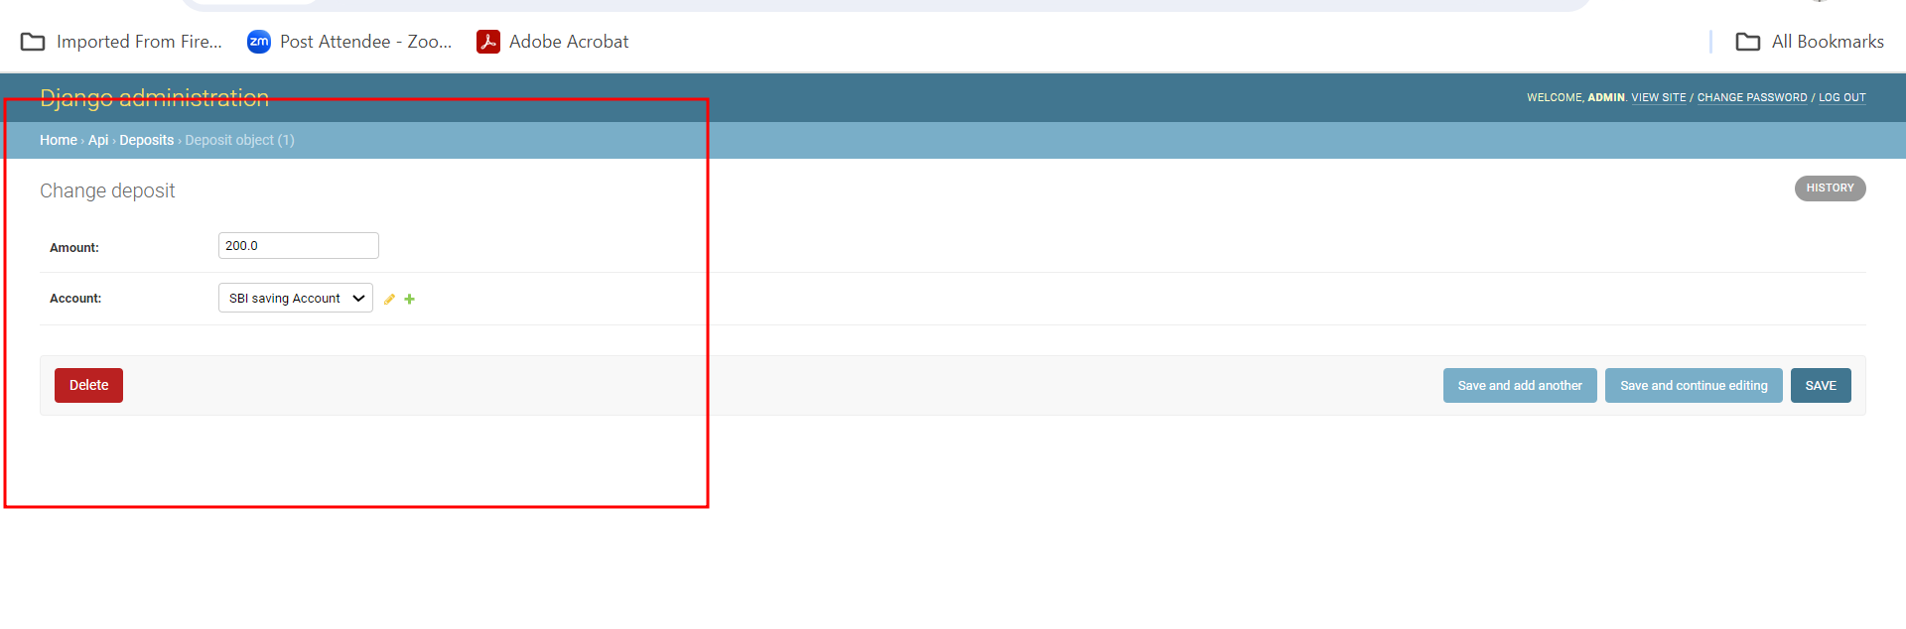

**Check service request**

